Working on our wellness at Wheatley Lane
Welcome to our very first wellbeing for parents and carers newsletter!
We think looking after our mental health and wellbeing should be a priority.
We have been working hard at looking after the children and staff at the school and we want to expand this so that we are supporting our parents and carers more.
We have a trained Nurture team in school who work with children who have been identified as needing additional emotional an and social support.
The team are Mrs Latham, Mrs Pollard and Mrs Hargreaves
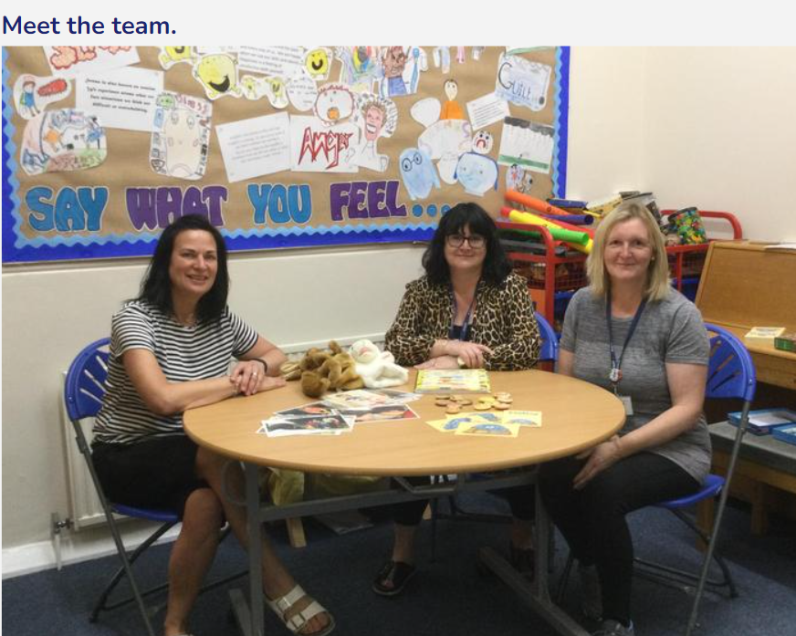
We have a pastoral team working in school that are here to support the whole school community in terms of their wellbeing.
The team are Maureen Thornborrow Pastor Richard Hoyle and Stella Brassington.
Mrs Brown works as the family support and SEND leader in school
Mrs Hargreaves is the wellbeing leader in school
We have a team of Wellbeing Ambassadors who help the children’s wellbeing.
The team are Thea, Spencer, Cara, Ethan,
Eva and Eliza.
5 ways to wellness
We have a focus in school that both staff and children try to work on. They are the 5 ways to wellness from mind.org
https://www.mind.org.uk/workplace/mental-health-at-work/taking-care-of-yourself/five-ways-to-wellbeing/
Connect is the first of the 5 that is quite an accessible one to try:
There is strong evidence that indicates that feeling close to, and valued by, other people is a fundamental human need and one that contributes to functioning well in the world.
It’s clear that social relationships are critical for promoting wellbeing and for acting as a buffer against mental ill health for people of all ages. With this in mind, try to do something different today and make connection. These are the suggestions form mind – you might be able to come up with something different – let us know!
- Talk to someone instead of sending an email
- Speak to someone new
- Ask how someone’s weekend was and really listen when they tell you
- Give a colleague a lift to work or share the journey home with them.

WE WANT YOUR INPUT!

We are thinking of starting some parent workshops – in the first instance for the infant classes.
We were wondering if this is something that you would be interested in doing?
There are a number of areas we could deliver if there was a take up interest such as:
1 – Understanding Emotions
2 - Being Brave
3 – Managing difficult emotions
4 – Understanding stress
5 – Understanding Change
6 – Release your resilience
7 - Building self-esteem
8 – NSPCC – PANTS
9- Healthy Relationships
10 – Bullying
11 - Keeping safe in the Community
12 – Online Safety
13 – Keeping safe in the home
14 – Healthy Eating
15 Move and Groove
Or it might be something else that you find you would like additional advice or support about such as bedtime routines, or healthy eating.

Please let me know so that we establish a list of bespoke workshops for you.

Also What time would work best to run these workshops for most parents?

These could be run in partnerships with our children and family wellbeing support service.

Let me know what you think
h.hargreaves@wheatleylane.lancs.sch.uk

The children and family wellbeing support service also provide groups at their centres around Pendle. Please see the flyers below:

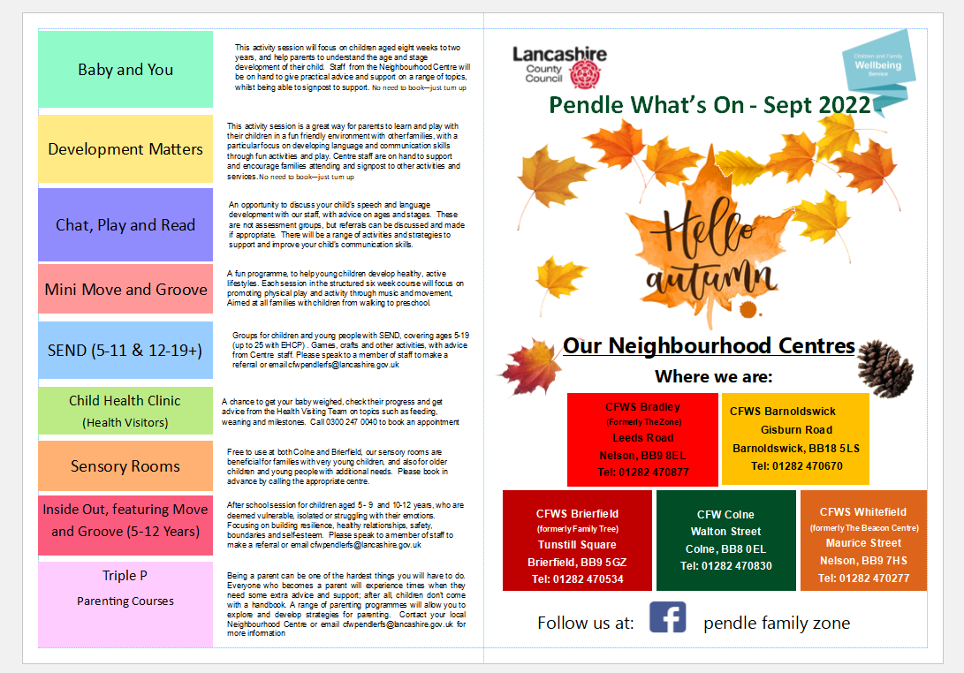

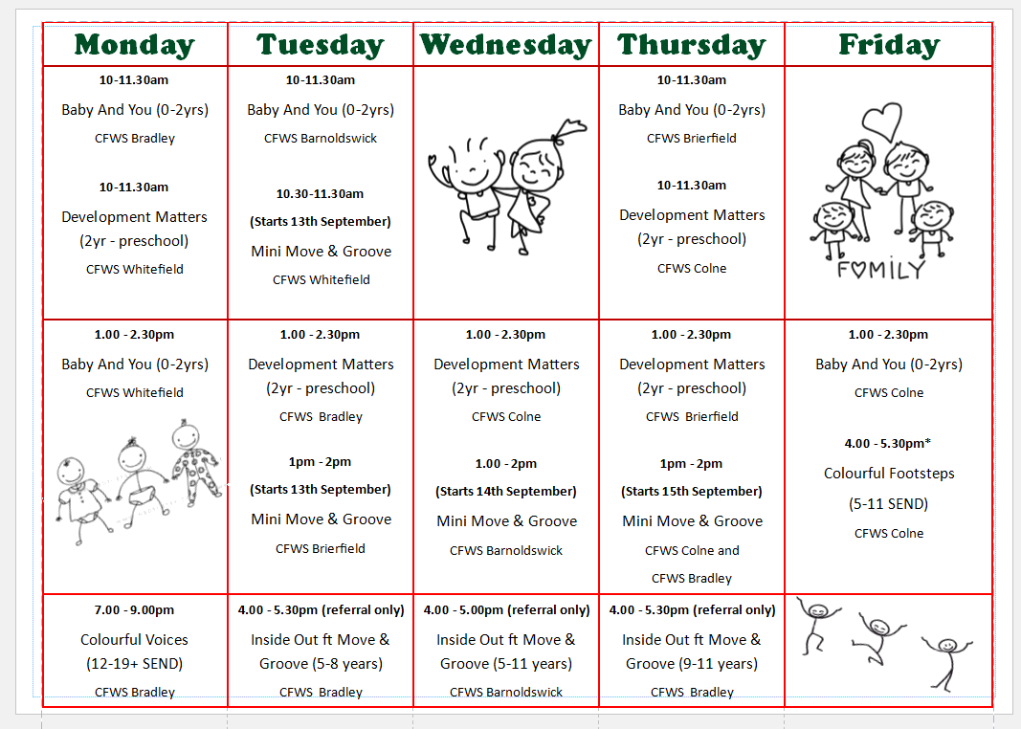

HRH Sepember 2022

Lancashire Walk and talk
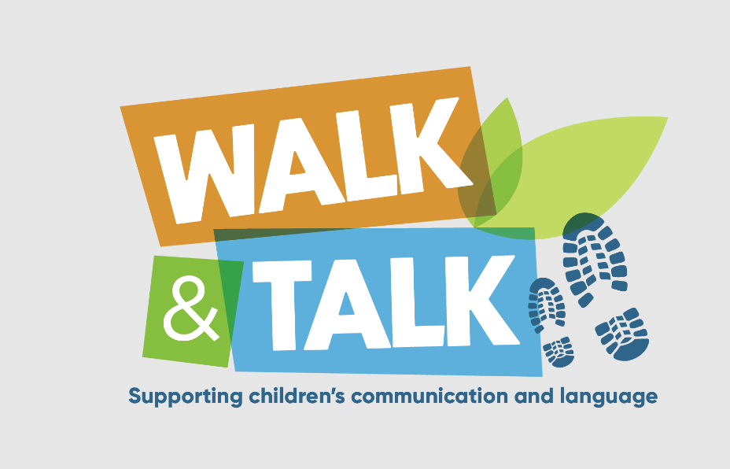
Walk and Talk is a new Lancashire campaign to promote the importance of communication and language for our youngest children.
There is a video link to watch if you are interested in doing this with your child
https://www.lancashire.gov.uk/early-years-support-and-training/parental-engagement-and-home-learning/walk-and-talk/

Aims of the campaign
We know nationally, Covid-19 has had a huge impact on children's communication and language and personal, social and emotional development. Focussing our attention through Walk and Talk will help children develop those vital skills they require for lifelong learning.
The Lancashire Early Years of Life Strategy emphasises the focus on "closing the word gap and improve child communications outcomes", achieving this through the home learning environment, early education environment and through early identification and intervention. The Walk and Talk campaign would support in achieving the aims of the strategy.
There are activity cards that provide discussion prompts.
Going on a walk helps to develop listening and attention skills which are essential building blocks for communication and language. We want children to use all their senses.
- listen to the birds
- look at the traffic on the road
- smell the freshly cut grass
- touch the bark on the tree
- taste their snack


