Promoting children and young people’s mental health and wellbeing.
Wheatley Lane Methodist School

As set out by The Department for Education, a whole school approach to mental health and wellbeing incorporates 8 key principles, which when applied consistently will contribute and promote improved mental health and wellbeing for our school community.
The 8 key principles
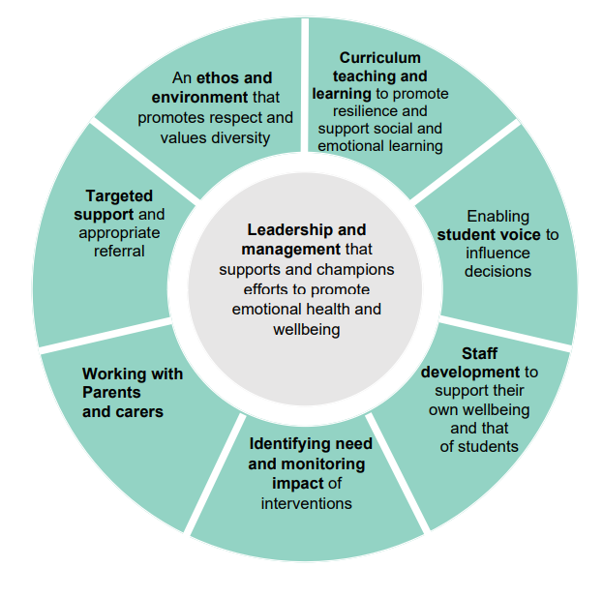

Leadership and management

- a Senior leadership team that champions efforts to promote health and wellbeing with one member being on the SLT specifically for wellbeing.
- Wellbeing member of the SLT having regular management time specifically for wellbeing initiatives.
- Wellbeing/Pastoral team as part of our supportive school governance – Stella Brassington (Chaplain/Pastoral) Maureen Thornborough (Pastoral),
NB Pastoral team members are consciously not on our Governing team as they are our employers but they feed back to the Governors regularly to report on wellbeing along with the school wellbeing lead.
- Wellbeing on every SLT and staff meeting agenda
- funding used to help children overcome barriers to learning – tutoring started with Year 5 and 6
- Funding for Specialists (child psychologist) brought into school for children/families with identified needs
- Funding provided for 3 members of staff to have undergone the ELSA training to provide a PASTORAL TEAM who give daily/weekly emotional support strategies
- SLT members working closely together to unify information giving and support eg DSL, SENDCo and Wellbeing leads working together to share information and liaise for best interventions and outcomes.
- A behaviour continuum as part of the behaviour policy so there is a structured approach for all to follow and clear next steps
- To proactively support National initiatives that prioritise Mental Health and wellbeing.
- To create a positive ethos and lead by example. Promoting a good work life balance priority for 2021-2022
- To actively support the 5 ways to wellness focus

NEXT STEPS

- look at the DFE respectful school communities tool to build upon our whole school approach

Ethos and Environment

- A positive values approach that openly talks about mental health and wellbeing and is proactively taught as part of the curriculum (PSHE)
- To have a check in board in every class that asks the children ‘how do you feel today?’ to monitor and react to changes in emotions
- A positive behaviour approach using the Restorative approach to behaviour – all staff members trained in this.
- A positive behaviour approach written by the children – the love charter.
- A mindful approach – after lunch children are asked to be mindful - for 1-2 minutes each day.
- To be part of the Pendle linking Schools project – To promote joint working between Primary Schools in geographical locations across Pendle which will allow for pupils from a mainly mono-cultural environment to come together for cross-cultural learning and engagement. To develop and deepen children and young people’s knowledge and understanding of identity/ies, diversity, equality and community. To provide opportunities for children to meet, build relationships, work together and contribute to the wider community. For parents to follow a course of learning alongside their children and become involved in socially active projects which develop cohesive cross-cultural relationship
- To have a range of extra-curricular activities to promote and extend children’s experiences
- To promote personal development in the experiences we offer as part of the curriculum – see PSHE/Personal development documentation.
- To promote a sense of belonging and importance within the school community – eg unconditional positive regard
- Buddy system for younger children in school to have an older buddy
NEXT STEPS
- To ensure our school environment and teaching resources promote a culturally diverse world with aspirational images and soundbites for children to reflect upon. eg Infant corridor mural.
- No outsiders programme to start in September to encourage inclusion and equality
- To develop and improve the EYFS outdoor learning area to promote physical development.
Curriculum teaching and learning

- Our curriculum priority is for teaching to promote learning and the acquisition of knowledge, raise achievement and promote the spiritual, moral, social and cultural development. This is done thought a broad and balanced curriculum and shared vision by all staff.
- Physical health and wellbeing is taught using the accredited PSHE association resources – including statutory content regarding relationships education. We have a spiral curriculum bespoke to our school.
- British Values are taught as part of our PSHE learning and referenced each PSHE lesson.
- A cross curricular approach – in particular P.E, R.E and Science.
- Being reactive to different world events (For example – Recovery curriculum taught after Covid)
- Being reactive to different times in the school year – eg coping with exam pressure, coping with transition periods
- Having transition visits as part of our curriculum in the Summer term for all classes

NEXT STEPS
- SLT to look at the whole school curriculum and the overarching principles – what learning experiences and skills do we want the children to leave Wheatley Lane with – whole school/staff approach and involving children to develop the curriculum.
Student voice

- An active school council
- Named wellbeing Ambassadors actively meeting weekly and working together for School and community wellbeing
- Pupil voice having rewritten the Behaviour charter (video available explaining what they did on the website).
- Wellbeing Ambassadors have completed a profile wheel. This questioned the children in how they feel on 12 different wellbeing areas and gave them a score of 1-10 eg how much sleep they got, friendships, hobbies, how they felt they were supported. Follow up work based on the priorities of the profile wheel.
- Subject leaders have all conducted pupil voice questionnaires as part of their monitoring cycle, fed back to whole staff and made recommendation for improvements named by the children.
Eg ART pupil voice – children want their art displayed in a prominent part in school as part of an art gallery. An art gallery will be a permanent hall display with framed art work (which changes each half term) as a direct result of pupil voice.

NEXT STEPS
- Develop subject specific advocates? Children who work alongside a subject lead to promote the subject in school and provide best subject experiences?
- Wellbeing ambassadors/school council further develop ideas for improvements during the play and lunch times – ‘circle of friends/buddy bench ideas, additional outdoor seating ideas, additional playtime equipment ideas.

Staff development

- Wellbeing policy in action
- wellbeing continuum of support
- Wellbeing charter based on trust, support, guidance, interest, happiness, balance, equality and inclusion
- An annual wellbeing focus – 2021-2022 using Mind five ways to wellnesshttps://www.mind.org.uk/workplace/mental-health-at-work/taking-care-of-yourself/five-ways-to-wellbeing/
- Termly newsletters signposting what is happening in school and signposting of support aswell as in the appendix of the wellbeing policy
- Annual emotional health screening to highlight areas that we need to improve on as a school or staff who need support.
- A buddy system where staff choose a ‘buddy’ of their choice with whom they can confidentially share and have time to ‘off load’ but also whom they can give positive support to and ‘check in’ with
- Encourage a sense of community by allowing opportunities for all staff to get together for shared experiences (lunch/breakfast) and reinforcing that all staff are important and having non-work related activities for staff.
- Keep staff wellbeing and development on the school agenda to normalise the process of speaking about wellbeing.
- A community wide acknowledgment that wellbeing is about self-care and taking ownership of one’s own wellbeing.
- School chaplain available for confidential support

NEXT STEPS
- Have a wellbeing staff training/meeting planned in for Autumn 2022.This could be reward based also?

Identifying needs and monitoring impact

- Recovery curriculum planned and taught as a response to Covid school closures
- emotions check in board in every classroom to monitor children’s wellbeing daily and give immediate support
- Ask it basket/worry jars in all classes for children to ask for support confidentially
- Wellbeing Ambassadors undergone training to support pupil population
- Wellbeing Ambassadors conducted wellbeing survey to assess needs
- Nurture team working in both KS1 and KS2 to support children with identified emotional needs
- Annual emotional/wellbeing screening of staff to identify areas of need

NEXT STEPS

- Annual staff screening due Autumn term 2022. To provide proactive and reactive wellbeing support.

Working with parents and carers

- Open door policy
- Weekly school communication – newsletter
- all teacher emails communicated to parents for direct school contact
- Annual parent questionnaire and actions taken from it to make improvements
- Home visits made by the sLT for any attendance issues
- Home visits made by the EYFS team to new school starters

NEXT STEPS

- Polling to see what sort of parenting support they would benefit from and what training they would attend
- Wellbeing newsletter for parents?

Targeted support

- Wellbeing policy in action
- wellbeing continuum of support
- Wellbeing charter based on trust, support, guidance, interest, happiness, balance, equality and inclusion
- To offer supervision to all members of staff on request/every term
- To provide confidential counselling to any member of staff who requests it
- Referral process in place for children with emotional needs that need support
- Nurture team working in both KS1 and KS2 to support children with identified emotional needs
- Wellbeing lead and SENDCo working in collaboration for any Early Help referrals needing to be made
- School nurse available for working at school, family and community level
- Educational phycologist working to support children with identified needs

NEXT STEPS

- School nurse family based support and training? Contact to see what they could provide bespoke to our school needs.

