PERSONAL DEVELOPMENT AT WHEATLEY LANE METHODIST PRIMARY SCHOOL.



Personal Development is at the heart of our school learning journey. It encourages, promotes, adopts and embeds a range of skills that allow children to be life-long learners and to be ‘the best they can be’

We support children to acquire the knowledge, understanding and skills they need to manage their lives, now and in the future.
As part of a whole-school approach, Personal development develops the qualities and attributes children need to thrive as individuals, family members and members of society.

The benefit to pupils of such an approach is to prepare them to manage many of the most critical opportunities, challenges and responsibilities they will face growing up. It also helps them to connect and apply the knowledge and understanding they learn in all subjects to practical, real-life situations while helping them to feel safe and secure enough to fulfil their academic potential.

Our PSHE curriculum and whole school values underpin our approach to our children’s personal development, ensuring we are developing every child’s social, spiritual, moral education, physical health and emotional wellbeing, and relationships education, whilst developing a fundamental understanding of British values.

We try to provide multiple opportunities and experiences for all children and these are opportunities for all, that go beyond the curriculum and that encourage all children to discover new interests and talents.

Infinite 8 strategy

We are part of the Epworth Trust. All Epworth trust schools follow a strategy called ‘The infinite 8 strategy’.
The ‘Infinite Eight’ strategy is designed to support our children’s personal development. The ‘Infinite Eight’ strategy offers eight core opportunities to all the children within Epworth Trust. These opportunities will be experienced over their primary school years and will hopefully leave a valuable impression on their lives It is an offer that takes into account the element of school life beyond the taught curriculum. By offering these opportunities, it is hoped that children will be active in their learning, enjoying the leisure to learn and follow personal journeys of self-discovery and reflection. It is important to note that this is not a process that can be measured with pre-determined outcomes, in fact it is not at all clear nor will we ever know the extent of the impact of these experiences on each child. However, it is hoped that it will support children on their way to become well-rounded individuals with the aspiration to be the best version of themselves.

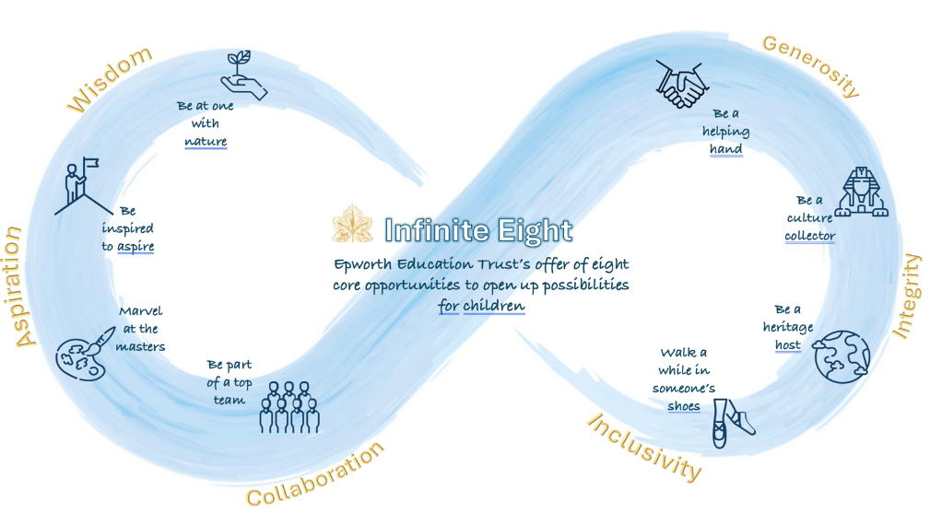

These opportunities have been designed with three key purposes in mind. These are to support schools:

- to align with Epworth Trust’s vision and values of Aspiration; Collaboration; Generosity; Inclusivity; Integrity and Wisdom

- to use the NHS’s five steps to promote good mental health. Learn new skills; Be active; Connect with others; Give to others; Be aware (mindfulness)

- to complement aspects of SMSC provision, promoting British Values

Within each of the eight opportunities is a set of core experiences (eighteen in total) that will be offered to our children throughout our Epworth Education Trust schools.

Please see appendix 1

Visits
Throughout the school year, we are fortunate to have various visitors to help children have experiences with people who have different talents, interests and knowledge.

Educational visits

Each class will have at least one educational visit booked per term.

Charitable events

The school supports a number of charitable events throughout the school year to encourage reflection of those who are in need and how we can support others.
We have a National awareness/National campaigns calendar to refer to.

Behaviour charter

The children have devised their own behaviour charter which has Love at its heart.
The areas that children work towards are:
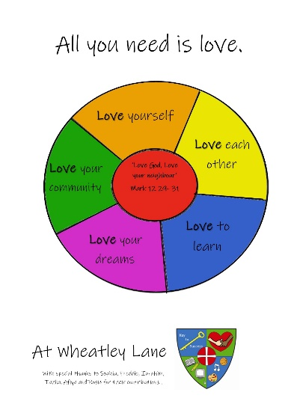

Wellbeing Ambassadors

We have wellbeing ambassadors who have had training in order to support the wellbeing of all pupils in school. The plan is for the ambassadors to raise awareness of positive well-being throughout the school community. The team leads a range of activities to support the positive well-being of their peers and the whole school community.
Extra curricular activities

We offer activities that cover a range of interests over the course of the year.

Community events

We link with the churches in the village as well as the active community leader to partake in village events and fund raisers.
We have planned for a community event in school - yet to be held due to Covid restrictions.

Methodist links

We link with the Church members to run co events. We support Church led events whilst the Church supports our school in school led events.

Parental links

We are proactive in our approach to supporting parents. We have a ‘meet the teacher’ session at the beginning of each term so all have the opportunity to be familiar with what their children will be experiencing for the coming year.
We have a parental partnership leaflet that is shared with all new parents.
We have a section on our website that has helpful guidance for areas of concern, including anxiety, sleep issues, self-esteem, grief and loss, trauma, and eating habits.
We have run a parent group and a coffee and chat session throughout the year.
We have a Mental Health Support team who can and have run workshops for any areas of need.
By supporting our parents we are giving them the tools needed to support their child.

Anti-Bullying
We promote an environment free from threat, harassment and any type of bullying behaviour. We will embrace the National Anti-Bullying week to highlight positive behaviour.

Equal opportunities

All our Personal development and enrichment activities are open to all children and our equal opportunities policy is inherent in ensuring all children have access to all experiences.

Please see additional documentation for personal development and experiences
For each year group.

Appendix 1

Delivering the Infinite Eight Strategy at Wheatley Lane Methodist Primary School

Infinite 8 Opportunities | Infinite 8  Core Experiences | YR | Y1 | Y2 | Y3 | Y4 | Y5 | Y6 | How will the school deliver the Infinite 8 offer?
Be at One with Nature | Go on a Welly Walk gathering natural materials for a work of art |  |  |  |  |  |  |  | YR Create works of art outdoors and invite parents/local community to view  Y3 Collect natural materials for Art
Be at One with Nature | Sleep under/see the stars |  |  |  |  |  |  |  | Y5 Camping on school field- before May half term?
Be at One with Nature | Have a food-to-fork experience |  |  |  |  |  |  |  | Infant classes – grow vegetables with Mrs Thornborrow and harvest them to create a vegetable feast to eat.  Y3 Eating seasonally topic – growing vegetables in the school garden harvest and make soup.
Be Part of a Top Team | Create a dream team and work on an outdoor challenge. |  |  |  |  |  |  |  | Y2 Problem solving activity at Outdoor Elements  Y5 To create a team go cart  Y6 Visit to Whitehough
Be Part of a Top Team | Dream big and make something as part of productive team |  |  |  |  |  |  |  | Y2 Humpty Dumpty challenge – design and build something to protect Humpty from breaking as he falls of the wall.  Y6 Enterprise Event – each team to be given £5, all profits to local charity
Be a Helping Hand | Organise a fundraiser for a local charity. |  |  |  | ▪ |  |  |  | RotaKids to lead on planning and organising fund-raising with children to choose charity  Whole school to support local food bank (Lent)  Whole school (Harvest) - global - ‘All We Can’ initiative  Choir Event for Edukids
Be a Helping Hand | Carry out an activity for the benefit of your community. |  |  |  |  |  |  |  | EYFS/KS1 Poetry recital for wider community  EYFS/KS1 Singing to the local residents on their way to the Nativity performance  Y3 Building Bridges fundraiser  Y4 Gardening at the local park
Be Inspired to Aspire | Listen to someone with an inspiring story. |  |  |  |  |  |  |  | Y1 Grandparents talk  Yr 2 People in the village tell us what it was like working in the mills  KS2 Careers Day Talk by parents/local business
Be Inspired to Aspire | Have a go at developing your talent by learning a fun new skill! |  |  |  |  |  |  |  | Y2 make Christmas decorations using clay skills learnt earlier in the year  YR Balance bikes  Y5 Bikeability
Walk a While in Someone’s Shoes | Learn more about Fairtrade |  |  |  |  |  |  |  | Whole school knowledge of what fair trade is
Walk a While in Someone’s Shoes | Take part in an Awareness Day and think about some people who may live differently to you. |  |  |  |  |  |  |  | Children’s mental Health Awareness week

Infinite 8 Opportunities | Infinite 8  Core Experiences | YR | Y1 | Y2 | Y3 | Y4 | Y5 | Y6 | How will the school deliver the Infinite 8 offer?
Marvel at the Masters | See a famous work by an artist.
Marvel at the Masters | Watch a thespian tread the boards. |  |  |  |  |  |  |  | Y5 trip to theatre
Marvel at the Masters | Be wowed by the work of a super scientist |  |  |  |  |  |  |  | Each year group to study a Scientist in Science Week
Marvel at the Masters | Feel the beat – hear live music |  |  |  |  |  |  |  | Yr4 Djembe drumming workshop  Y5 trip to Liverpool Philharmonic at Guild Hall
Be a Culture Collector | Learn a fun fact on a museum visit. |  |  |  |  |  |  |  | Y6Trip to Yorvik and the York Railway Museum
Be a Culture Collector | Have a quiet moment in a place of worship |  |  |  |  |  |  |  | Y2 and Y6 visit to the Mosque
refreshments | Connect the generations and host a heritage event inviting older people in the community. |  |  |  |  |  |  |  | YR Mother/granmother morning  Y1/YR Grandparents sharing My Stories of School/life in Fence  Infant classes World book day book sharing  Y4- Country dancing  Y4 – Play traditional sports such as rounders and cricket with parents and grandparents  Y5 Sing along with grandparents  Y6 – Serve cream teas

HRH 2024

