Autumn 1 | All about me! | Baseline Assessment – draw a picture of my family (assess dominant hand, levels of control and language/vocabulary). Modelling of classroom resources  Phonics introduction – focus on recognition, blending VC/CVC words. Lots of creative activities on formation, exploring line and control and name recognition,  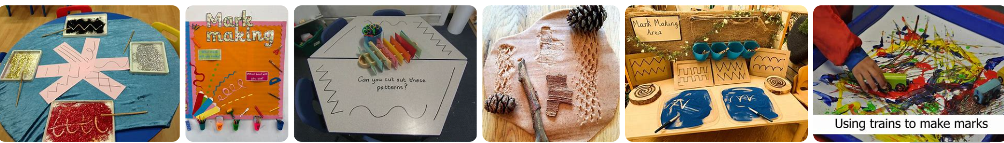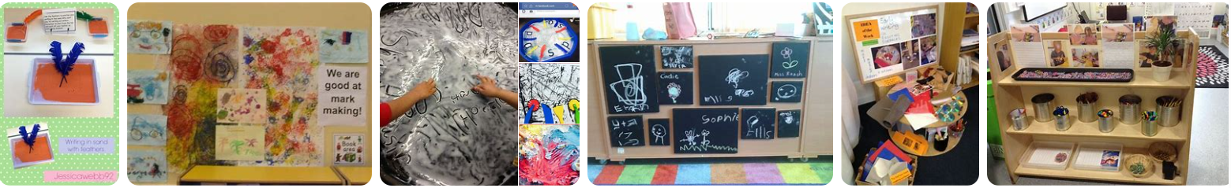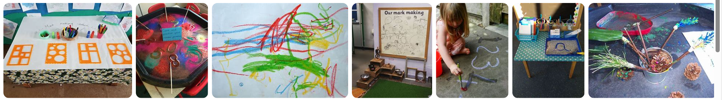
  Week 3  The family book  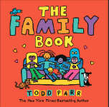  Draw and label your family  Write your own name | Week 4  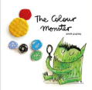  The colour monster  Draw and colour your favourite colour monster.  Decide which land he lives in? The land of  Sssss  Aaaaa  Ttttttt  Pppppp | Week 5  Poetry recital  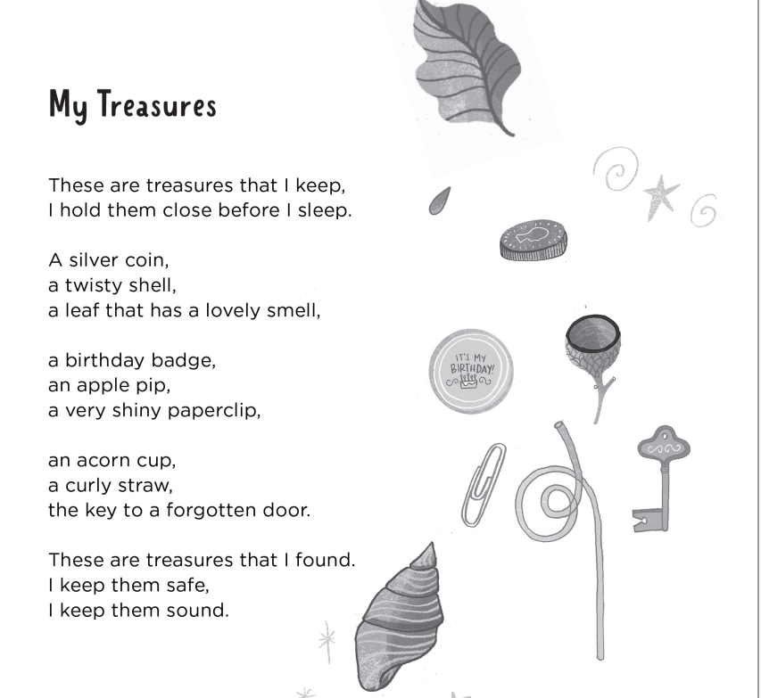  By Kate Wakeling | Week 6  Friendship animation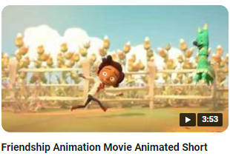  Draw a picture of being a kind friend.  Make a special friend recipe.  Tip, tap, pat to make your picture come to life. | The leaf man  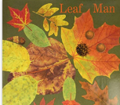  Find the leaf man.  Describe where he is.  Man on a mat.  Man on a dog.  Man on pin.  Man is sat.
Story basket | 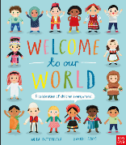  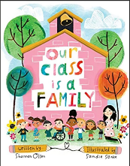  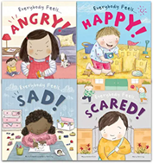  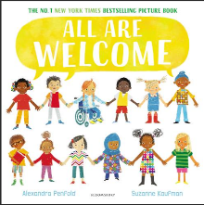  Elmer  Owl Babies  Ruby’s Worry  Meesha Makes Friends  Ravi’s Roar  Tilda tries again  Tilda Tries Again  The See Saw  Perfectly Norman  Pumpkin soup
Wheatley Lane Primary School- Reception Weekly Literacy Focused Outcomes
Possible Outcomes: Lists, labels, tags, stories, phone calls, stories, letters (apology/complaint) speech bubbles, diary (recount), note to someone, lost/wanted poster (persuasion), instructions (explanation/procedure), information

 | Theme | Week 1 | Week 2 | Week 3 | Week 4 | Week 5 | Week 6
Autumn 2 | Sparkle and Shine  (celebrations and festivals) | Rama and Sita  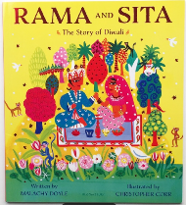  How would you rescue Sita? Draw a picture.  The monkeys built a bridge, I would fly a helicopter with a long ladder. In my helicopter I would have net, a big torch, a map, and a long rope ladder.  I can get Sita.  Sita left her jewels in our classroom. Where did she leave them?  It is on a…  Sita  Rescue  Diwali  Festival  Celebration | Poetry  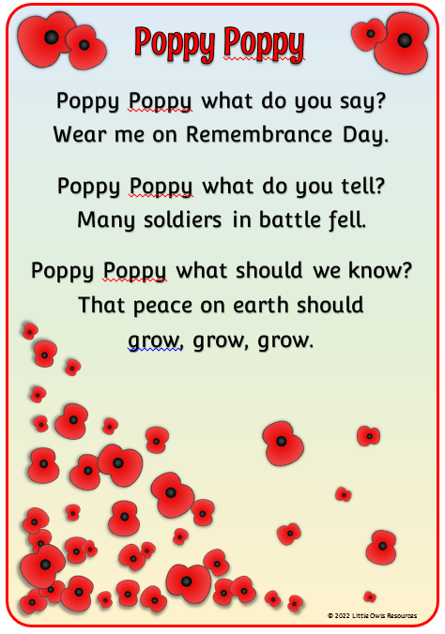  Recite and perform the poem ‘poppy, poppy’  Remember  Poppy  Soldier  Silence  Past | Pink panther and pals-animation  Party for one  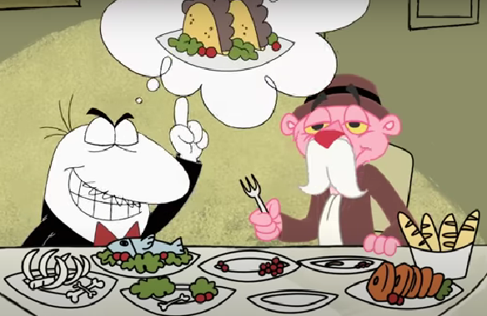  How would you sneak into the restaurant?  Draw and write about it.  I can go into it on a…  Describe your transport…  It can dig  It can dip  It can spin  It can map  It can tip  sneaky  invisible  mischievous  furious  persistent | Jesus’ Christmas party- Nicholas Allan  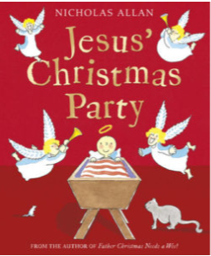  Can we make some signs for all of the people in the nativity, so they don’t wake Jesus up-  Stop Jesus is in the cot.  The noisy angels are still singing, the wise men are still shouting and the shepherds are still clattering. We need to make them another note.  Stop Jesus must nap.  Stable  Innkeeper  Register  Slammed  Chorus | The Christmas pine- Julia Donaldson  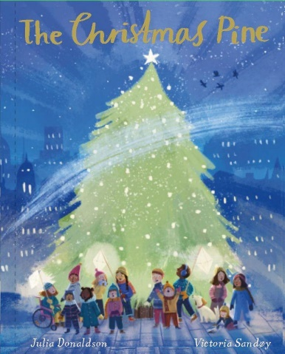  Invent a way to transport your tree from Norway to London  The decorations have gone missing…. I wonder which Christmas stinker has stolen them...  ancient  soaring  remote  gape  absent | Pingu’s family celebrate Christmas  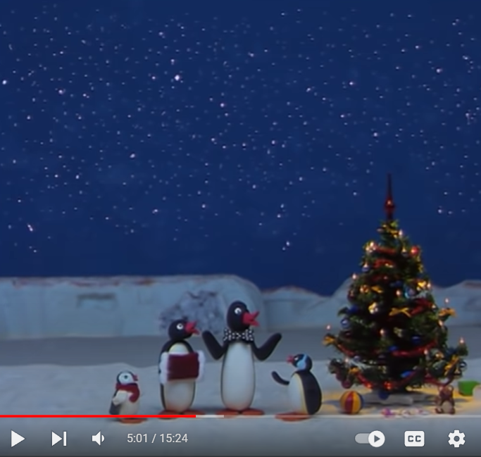  How do you celebrate Christmas with your family?  I help my dad.  I go to bed.  Brr, it looks chilly singing round the Christmas tree. Pingu’s baby brother isn’t sure what to do, lets tell him…  Put on a hat and sing.  Special  Sensible  Furious  Busy  Christmas
Story basket | 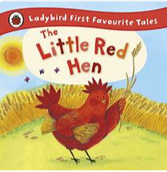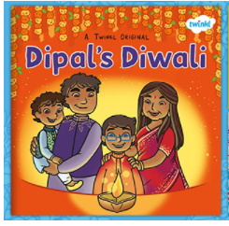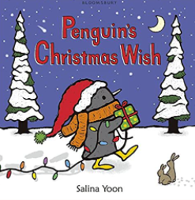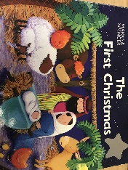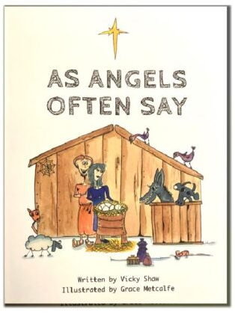  Percy park-keeper  Stickman  The Christmas wish  The nativity story  Maisies Christmas letters

Spring 1 | Once upon a time | Gingerbread Man  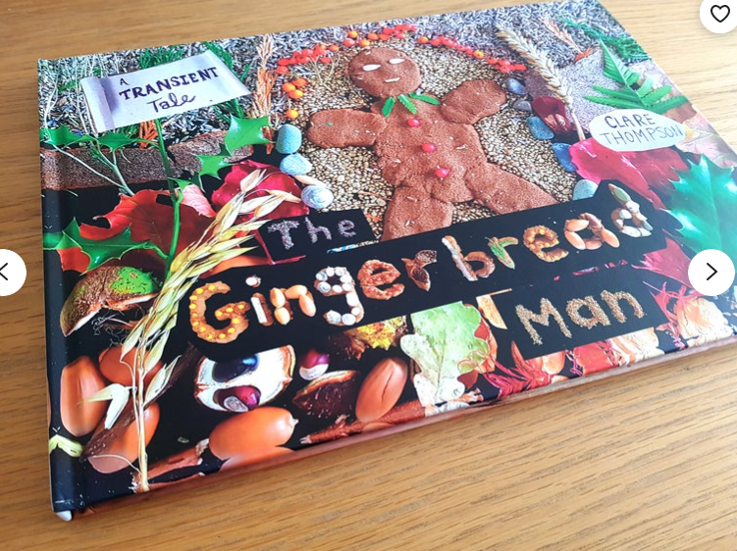  The gingerbread man tried to escape. He’s been running all around the school grounds. Can you investigate where he’s been? Make telescopes to help you find him.  Man in the bin.  Man on the mat.  Man on the grass.  Man in the hat.  Man on the bat.  Make a story map to show where he has been. Perhaps we can find him and tell him not to be scared.  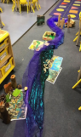  Soggy  Leap  Cunning  Accelerate  Chase | Goldilocks  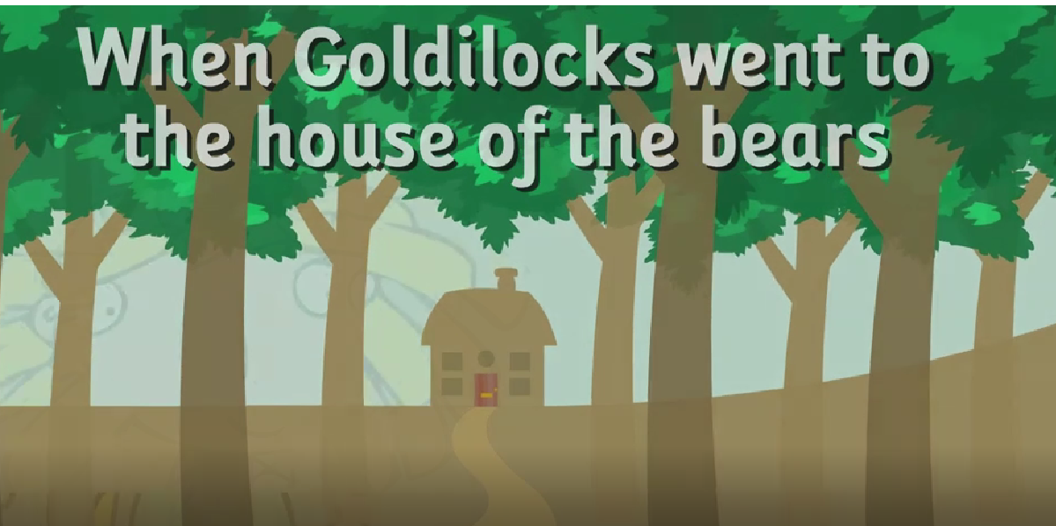  Recite and perform Goldilocks poem.  Ran  Counted  Huge  Small  Tiny | Roald Dahl  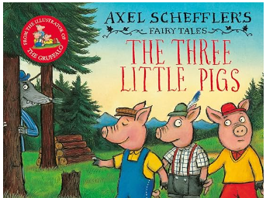  Warn the pigs about the big bad wolf. Pigs the wolf will huff and puff. The wolf is big and bad.  The pigs decide to set some traps for the wolf. What could they be?  I will trap you wolf.  I will trick you wolf.  Construct  Sturdy  Flimsy  Scarper  Exhale | Little red hen  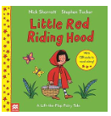  If you were going on a long journey what would you pack in a bag for grandma?  I will pack a bag.  The bag will be full.  If you were the wolf. How would you trick little red riding hood?  I will put on a mask.  I will put on a hat.  Scary  Sly  Curious  Startled  Wicked | The three billy goats gruff.  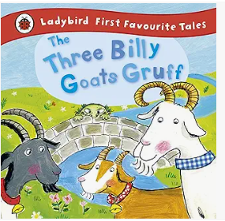  If only the Troll had a sign to show the goats what a grumpy troll he was. Let’s make one.  Do not cross.  I am a troll.  I am mad.  Do not trip trap.  There’s been a flood and the bridge got washed away. How can we cross the river?  I will cross from the land on…  Fearless  Gruesome  Suddenly  Determined  Bamboozle | The enormous turnip  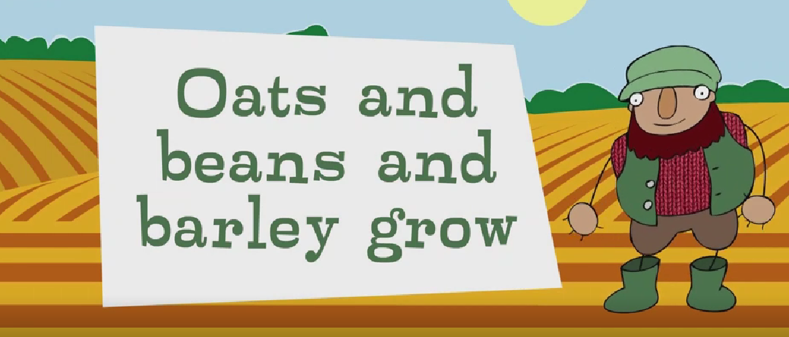  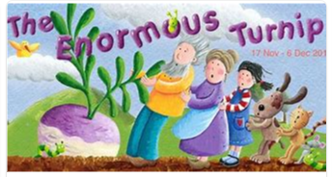  Recite and perform  Oats and beans and barley grow.  Barley  Sow  Enormous  Turnip  Tug
Story basket  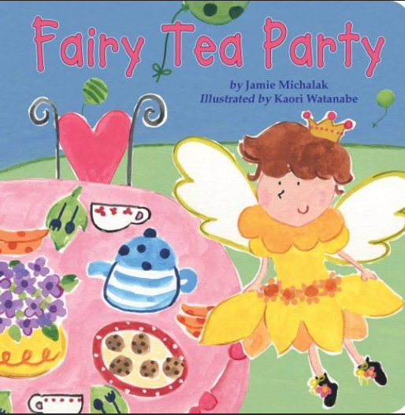 | 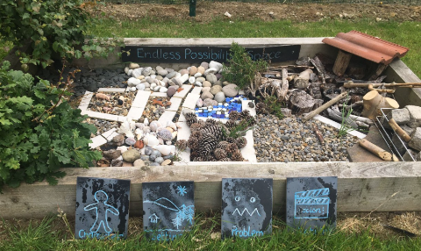  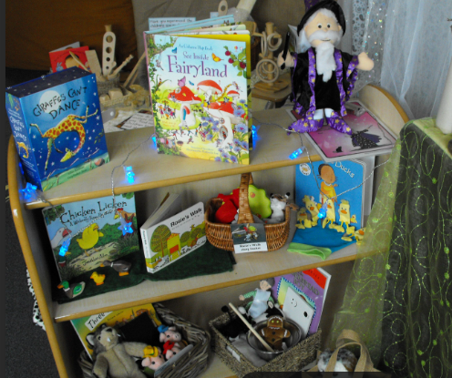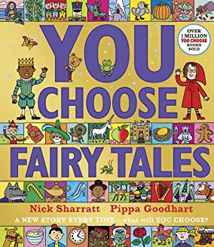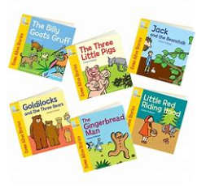  .
 | Theme | Week 1 | Week 2 | Week 3 | Week 4 | Week 5 | Week 6
Spring 2 | Come outside | Superworm  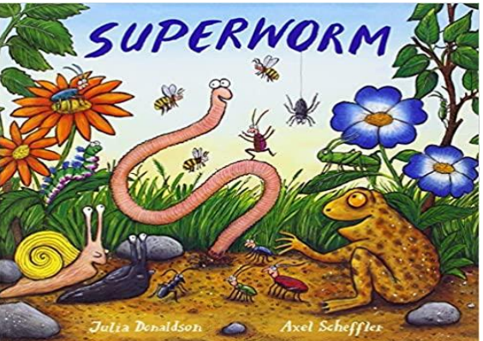  Oh dear, a creature with a tail needs rescuing. Which creature would superworm save? What would be the problem?  The pain is in her tail.  It’s the middle of the night and the animal needs rescuing from up high by superworm. How will you rescue her?  We are up high at night  Rescue  Pain  Hero  Creature  Stretch | 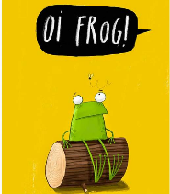  Oi frog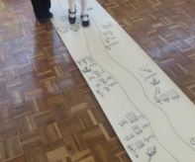  Using the rhyming basket, carry on the rhyming string. Write and draw your ideas on our big roll paper.  Choose three ideas from our class rhyming string to make your own poem.  Rhyme  Frog  Perch  Recommendation | Come outside- Animation  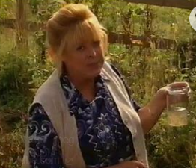  Frogs  Write about the frog life cycle-  The eggs are in the pond.  The froglet has a tail.  The frog is in the pond.  Write about the frog-  The frog likes to eat bugs.  The frog is in the pond.  The frog jumps high.  The frog can croak.  Frog spawn  Tadpole  Froglet  Croak | Jaspers beanstalk  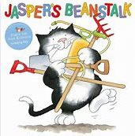  Jasper was very impatient waiting for his beanstalk to grow. Perhaps we could help, lets make a growing spell.  Growing spell –  Perform  Tall tall tall  Grow, grow, grow  Stretch, stretch, stretch  How does the beanstalk feel? (look at different pictures)  I’m a beanstalk, bursting…  I’m a beanstalk stretching..... Collect words – act out growing, bursting, stretch, twisting, climbing.  Twisting  Stretching  Climbing  Bursting  Growing | Jack and the beanstalk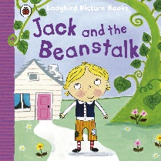  Eek Jack is hiding in the giants house, what did he see? Draw a picture of the giant sat in his kitchen.  Jack took a peek up high.  How could Jack quickly get up and down the stalk?  Jack will zoom up to the top.  Flee  Venture  Fortune  Treasure | Morph- Animation-Flowers  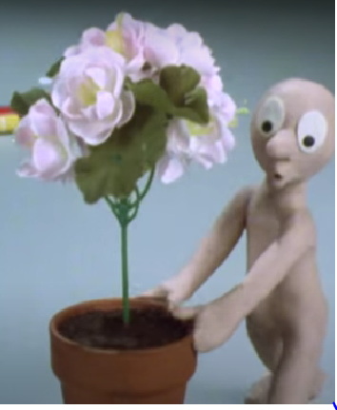  If you grew a plant what would you want it to look like?  My plant will be big.  My plant has big petals.  My plant will need a big pot.  Wow you managed to grow a big plant using super food. Your plant now has a super power what will it be?  My plant can hug.  My plant can run.  My plant can sing.  Blossom  Wilt  Sprout  Prune
Story basket | 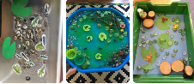  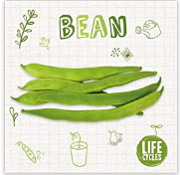  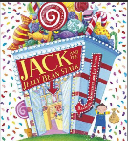  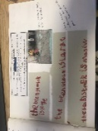  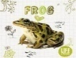  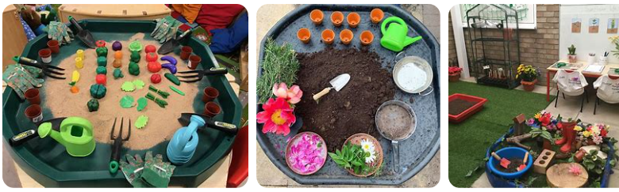  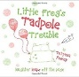  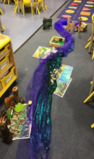  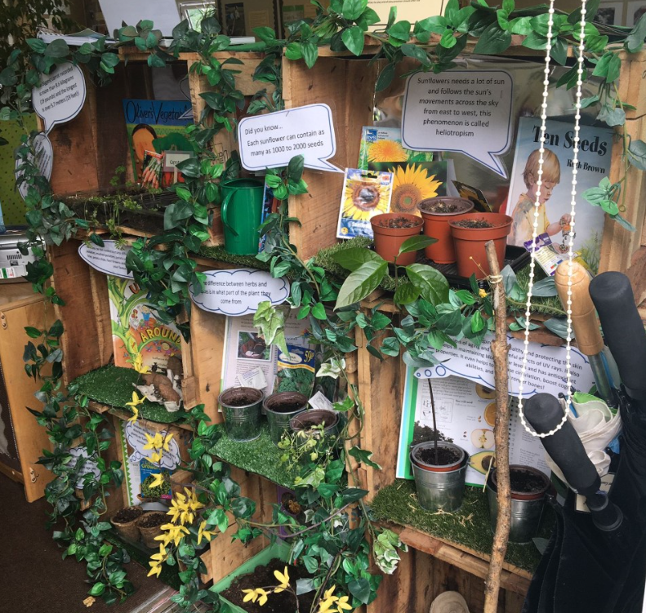
 |  | Week 1 | Week 2 | Week 3 | Week 4 | Week 5 | Week 6
Summer 1 | A ticket to ride | Blue monster wants it all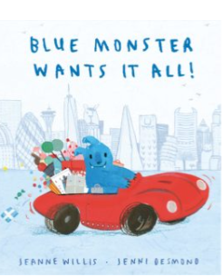 | You can’t call an elephant in an emergency.  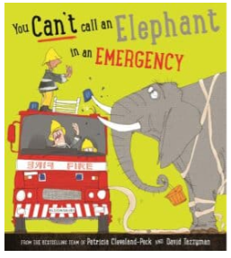 | The hundred decker bus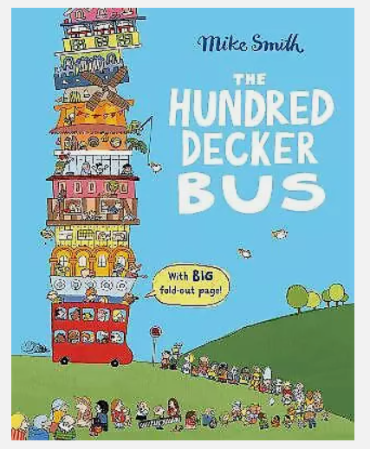 | 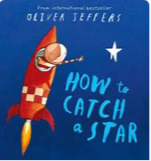  How to catch a star | The way back home  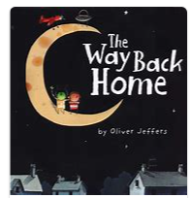  How would you feel if you were stuck on the moon? | Bananaman-Animation  The alien planet  
Story basket | 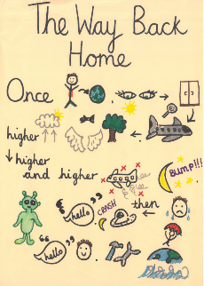  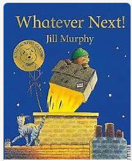  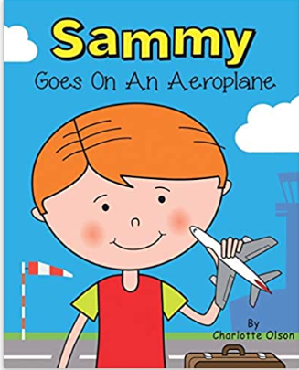 . 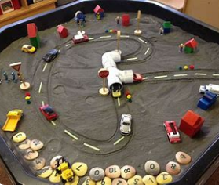  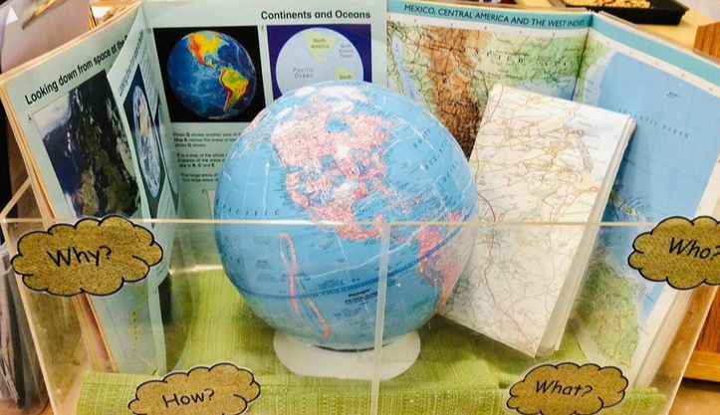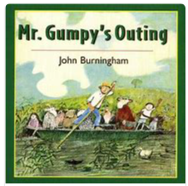
 |  | Week 1 | Week 2 | Week 3 | Week 4 | Week 5 | Week 6
Summer 2 |  | The night pirates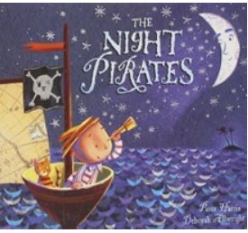  Read the first four pages (up to 'Tom was a little boy about to have an adventure'). Before reading on, predict what the adventure might be. | 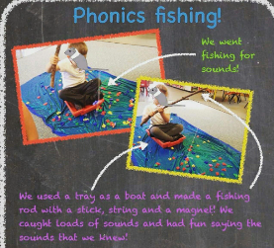  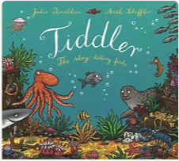  Tiddler | 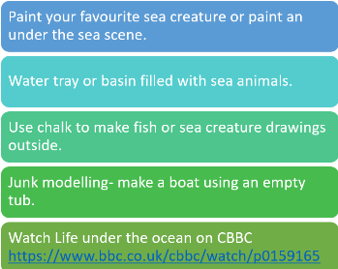  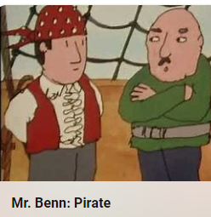  Mr Benn Pirate | 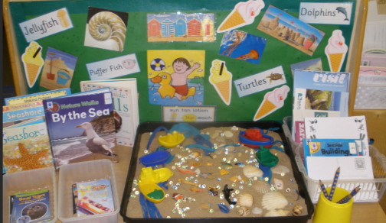  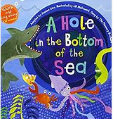  A hole at the bottom of the sea | 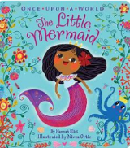  The little mermaid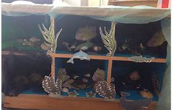 | The captain and the kids-Animation  At the beach  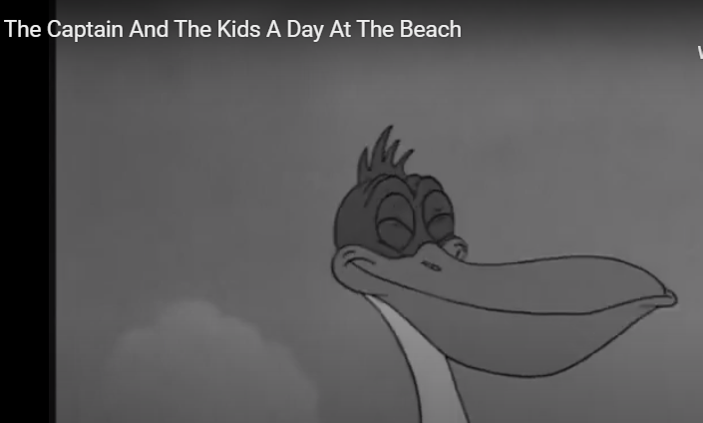
Story basket | 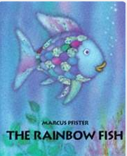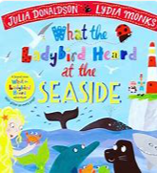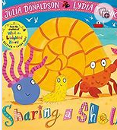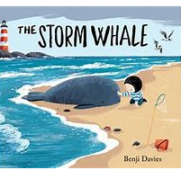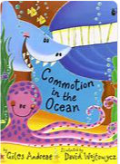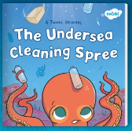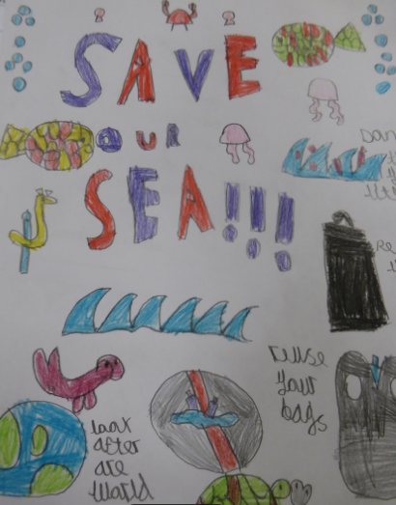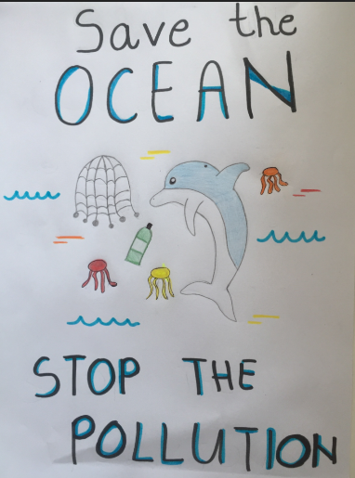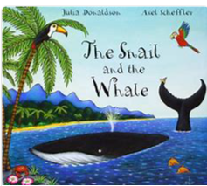  EYFS: Listen and Play - Under the sea - BBC Teach  Commotion in the oceanRead the poems to the children without telling them which animal they are about and see if they can guess which animal it is describing. Children then write clues about their favourite sea creature. Can it rhyme? Create a bank of rhyming words prior. Fish>dish. Sea>tea. Boat>float. Add it to a whole class lift the flap book (add postit notes for flaps).  Mrs Pirate-Make a list for all the things you would need if you were a pirate. Can we make it rhyme? A box of tea, a tiny flea.  A bag of maps, some hidden traps. A coloured flag, a large bag. Under the sea cleaning spree Make information posterexplaining how we mustn’t pollute the sea. We must put litter in the bin.

