British Values at Wheatley Lane Methodist School
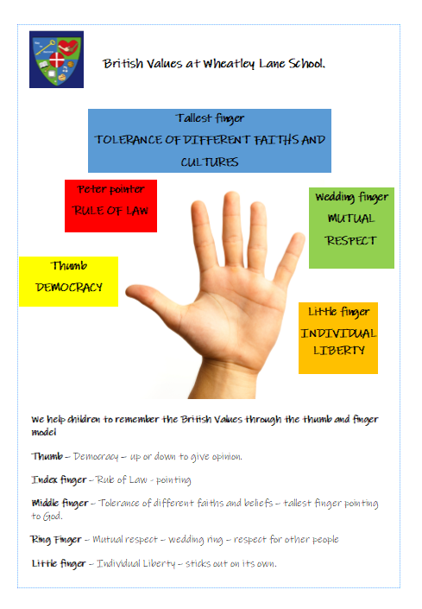

The Department for Education have reinforced the need “to create and enforce a clear and rigorous expectation on all schools to promote the fundamental British Values of democracy, the rule of law, individual liberty and mutual respect and tolerance of those with different faiths and beliefs.”

At Wheatley Lane we uphold and teach pupils about British values which are defined as:
- Democracy
- The rule of law
- Tolerance
- Mutual respect
- Individual liberty

These values are taught though Personal, Social, Health and Emotional (PSHE) and Religious Education (R.E). We also teach British Values through delivering a range of whole school Worships and through teaching a broad and balanced curriculum. The Values are reinforced through the school in the following ways:

British Values

- Mutual Respect: Language of respect, school values, supporting each other, reinforced through our behaviour policy, home-school agreement, displays and school ethos.
- Democracy: School council, Wellbeing ambassadors, Class rules, Children’s learning charter for PSHE and circle time, sports leaders, lunchtime buddies. Restorative approach to behaviour
- Celebrating national events: The Jubilee, National mourning for the Queen,
- Individual Liberty: Freedom to make choices, clear behaviour policy, choice of learning challenges, empowering Democracy: School council.
- Working with parents: information sessions – like meet the teacher, how we teach phonics, stay and learn sessions and celebration events,
- Tolerance of different faiths: Class discussions, circle time, worships, RE, visitors to school, Anti-bullying behaviour, school ethos, Pendle Partnership lining schools with different cultural backgrounds.
- Rule of Law: Class rules, behaviour policy and rewards, visits from the police, fire brigade, positive relationships with children and parents
- Celebrating national sporting events and achievements Visiting Olympian and Paralympian

Spiritual development
- A strong Christian ethos that celebrates faith and is inclusive
- Strong pastoral support in school from the Pastor and pastoral support workers
- Circle times and opportunities for children to share their ideas in class
- A broad and balanced curriculum is taught
- Children are given the opportunity to express their feelings and emotions – such as each class having an emotions check in/self-register
- Ability to give and receive constructive feedback
- Celebration of a range of religious festivals
- Regular prayer/reflective moments
- Regular Church and religious building visits

Moral development
- School worship with themes that discuss a range of issues which encourage discussion and fairness. Autumn 2022 has a full programme of whole class worships addressing the Protected Characteristics.
- Current events in the world are addressed and discussed – using Picture News as a weekly stimulus for discussion
- Children, staff and parents are proud of the school environment that is looked after and respected by all.
- PSHE curriculum addressing themes throughout both key stages on consequences, friendship groups, overcoming difficulties, conflict resolution, healthy relationships, drug education,
- Whole school reward system – we use Marvellous me
- Love charter – asking children to be responsible and take ownership of their own development in terms of loving themselves, loving each other, loving their dream, loving to learn, loving their community and loving God.

Social development
- Y6 supporting other children with their transition.
- Y6 showing new and potential parents around school.
- Yr 6 and EYFS Buddies
- Children take part in a range of councils including school council, worship leaders, Sports leaders, Wellbeing Ambassadors and we are introducing the idea of learning leaders to some subjects.
- We work hard on our relationship with parents through ‘stay and play’ sessions in EYFS, meet the teacher meetings, class worships,
- Children visit other schools for transition and sporting events
- Pendle linking project for children to interact with children of their own age that come from different cultural backgrounds.
- Carol singing
- Many sporting events facilitated by an enthusiastic PE lead and the Sports Premium

Cultural development
- Displays round the school reinforce the schools values.
- Opportunities through the curriculum to extend their knowledge of other cultures e.g. Art and Design and learning about different artists, English using diverse reading material in terms of Authors and contexts, R.E. learning about different faiths and cultural traditions.
- Fund raising for other charities, causes that they have a pertinent interest in – for example Manchester Children’s hospital after one of our (now ex) pupils is having treatment there. Church links and for school funds.
- School elections: School council, Worship leaders, Sports leaders, Wellbeing Ambassadors
- Charanga music – introduction and teaching of music from around the world.
- Music Service – the children in Y3 learn to play the Ukulele
- Artist of the month – learning about Artists from all over the world and different eras
- After school Enrichment
- School visits to galleries and museums
- School visitors Year 2 – Artist in residence. Year 2 and 6 Fire brigade visits.

