No outsiders programme
To address protected characteristics aswell as the Anti bullying agenda
Worship for the first 7 weeks of the Autumn term (2022)will be prioritised to address the Protected characteristics/Equality Act as part of our ‘All are welcome’ vision.
This is inherent in our Christian vision and central to our view on behaviour and conduct:
Love the Lord your God with all your heart and with all your soul and with all your mind and with all your strength. The second is this: Love your neighbour as yourself. There is no commandment greater than these.”
Mark 12 29-31
Jesus was inclusive of everyone and we want to reflect this as part of the programme. Thus there is a Biblical reference or story as part of the weekly focus.
Suggested programme as below. This will be delivered in class, by the class teacher and age appropriately. Children will have opportunities to discuss in an open and safe environement.

week | Theme | Resource | Additional notes | Biblical reference
1 | Family  Family make up  Including marriage and civil partnership | A real family  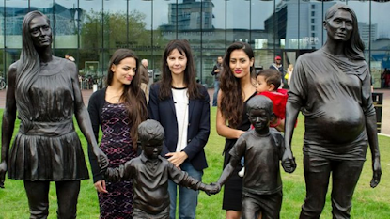  https://www.bbc.co.uk/news/uk-england-birmingham-29834704  The photo shows a statue in Birmingham City Centre called, "A real Birmingham family.". Ask children to describe the family and ask who are the people in the photo.  The people standing behind the photo are the family used for the statue and the sculptor, Gillian Wearing, who stands in the middle.  The two woman depicted in the photo are sisters, Roma and Emma Jones and their children, Kyan and Shaye.  Gillian said she wanted to show that the idea of what makes a family isn't fixed. She liked how the sisters spoke of their closeness and how they supported each other.  But not everyone agreed that this showed a real family. Nigel and Angela Passey argued that the statue did not represent a typical family and there should be a dad; "It doesn't portray a family as it should be," said Angela.  On social media many people praised the statue but some argued it was not representative of Birmingham:  "Why is there 2 women? There should be a mum and a dad and two kids. It's a confusing sculpture in my opinion."  "Would be nice to see other representations, maybe with a father? Bit demoralising for dads this one."  "Where's Dad? Don't men count these days?"  Keep this final response to the end of the discussion so that children form their own responses before hearing it:  In answer to these comments, someone wrote, "No such thing as a "real" family. A family can be a anyone, it's who you love and look after and cherish that matters, whether that be Mum and Dad and children or 2 dads and children or just a loving couple with no children. Families come in all shapes and sizes, it's not one size fits all."  - why do you think Birmingham wanted a statue showing a family in the city centre?  - why call it "A real Birmingham family"?  - why do you think Gillian chose two sisters as her models?  - "the idea of what makes a family isn't fixed" what does that mean?  - lots of people like the statue, but there are some comments from people who disagree with the statue, why?  - is the statue demoralising for dads? what does that mean?  - "Don't men count these days?" what does this person mean by that?  - what does representation mean? Do you think dads under represented in society today?  - how do you think it feels to never see yourself represented in art or media? Do we see dads in media? Can you think of an advert that shows a family with a dad in it?  - "It's a confusing sculpture in my opinion." why do you think this person is confused?  - How would you respond to these points?  - does the statue show a "real family"?  - read the final comment made in response to comments questioning the statue. What does this person argue about family? What do you think?  - what can we learn from Birmingham in this story?  - what can we learn from Gillian and from Roma and Emma?  - why is this about No Outsiders? | See powerpoint. | Ruth and Naomi  The prodigal son
2 | Age  You can do anything whatever age you are | A world without ageism  Captain Sir Tom united the nation and gave us hope when it was needed most. An ordinary man at the age of 99 walking laps of his garden.  Through The Captain Tom Foundation, you have helped us create a legacy - supporting those in our community who struggle to be heard.  The Foundation has done amazing work, supporting causes close to Captain Sir Tom’s heart and close to ours.  Work only possible through the support you have given, you - individuals around the world who recognise the importance of Captain Sir Tom’s message.  We are combating ageism within our society, being the voice of the unheard and revolutionising the way society views ageing | The boy in the tent | Sarah
3 | Race  All are equal | 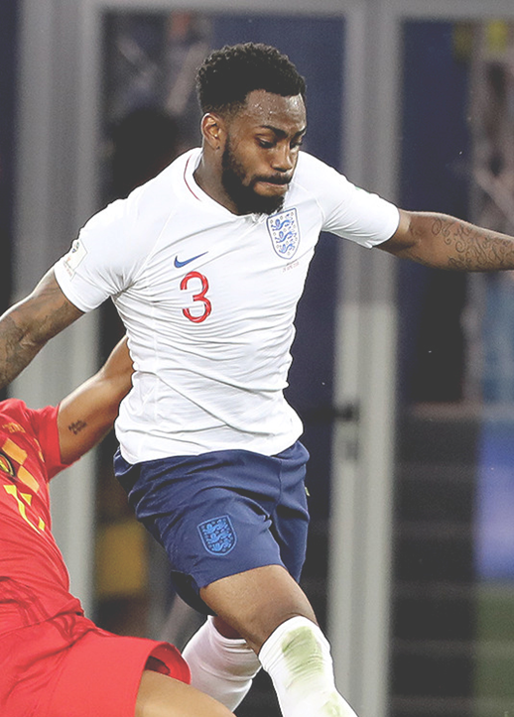  Racism in football has hit headlines time and time again. Several high-profile names have spoken out regarding racist abuse received by supporters and fans. England player Danny Rose was subjected to racist abuse during a game against Montenegro in March, 2019.  As a result of the racist abuse, Rose said he ‘can’t wait to see the back’ of football and many players, managers and fans have supported him and are arguing that racist, abusive behaviour should be severely punished.  Raheem Sterling, another England player, said that ‘if you walk off, they win’ but wasn't sure he alone could challenge racism in society by simply speaking out, adding that “It's something that happened before I was born and before my parents were born.” |  | The Good Samaritan
4 | Religion and belief  All are respected | Use the book ‘hats of faith’ (Lisa Fenton recommendation from RE conference). |  | Similarities between different faiths and Christianity – linking Islam and Judaism
5 | Gender  No discrimination | 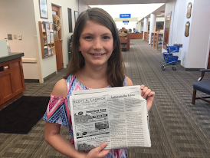  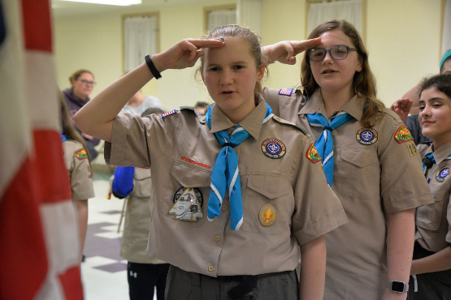  A 12 year old girl wrote a letter to the editor of her local newspaper about a remark make by an announcer at a scout parade.  Julianne Speyer was marching with the Chesterland, Ohio Girl Scouts as part of a 4th July parade. Julianne's troop were marching behind the Chesterland Boy Scouts and as they passed the announcer, he remarked over the loud speakers that the boys were, "future leaders of America" while the girls were, "Just having fun."  Julianne was offended by these remarks and decided to remind people that girls can be whatever they wanted to be. She wrote an open letter to the editor of her local newspaper, which quickly went viral:  "My name is Julianne Speyer. I am 12 years old and I would like to inform you of how offended and disappointed I am by the announcer of the Chesterland's 4th July parade's comment about the Girl Scouts and Boy Scouts. The announcer labelled the Boy Scouts as 'future leaders of America' and he said the Girl Scouts were "just having fun." I found this comment very sexist and patronising. I would appreciate it if you would help me to let other people know how much this kind of thing happens and how bad it is. I feel it is an insult to both girls and women of all ages. This kind of thing happens way too much and it's not OK at all.  I have always been taught that if you think something is unjust, change it. So this is how I am making a change. Thank you for listening to me and I hope you can help me."  Julianne's letter went viral across America yet there was no response from the announcer or parade organisers.  Eventually the parade organisers issue a statement in response to the letter:  "There was an unfortunate misunderstanding of two unrelated comments. The announcer is a volunteer and made an observation that participants were enjoying the parade, with no disrespect intended."  Julianne later commented, "You don't want to judge people based on their sex. Maybe, in the future if no-one beats me to the job, I'll be the first girl president. I could scream the message that girls can be anything they want to be. They can be in charge someday. We can be the leaders of America,"  Julianne received a letter from former Secretary of State, Hilary Clinton, praising Julianne for using her voice and speaking up; "Never forget that you are valuable, powerful and worthy of every opportunity to fulfil your potential."  - what are the scouts?  - have girls always been accepted in scout groups? (scouts were formed in 1910 and girls were allowed to join in 1976)  - why do you think for so long girls were not allowed to join scouts?  - By commenting on Boy Scouts being future leaders of America and Girl Scouts as having fun, what does this show about the attitudes of the announcer?  - why was Julianne offended?  - what is a "letter to the editor"? what is an open letter?  - What is the name for the way Julianne writes (formal)- why is she writing in that way? What would in informal letter sound like?  - why do you think the letter went viral?  - why do you think the announcer never responded?  - Look at the response from the organisers; were the two comments unrelated? Is this a misunderstanding? Do you think there is anything missing from that response? (an apology?)  - what would a better response look like?  - "You don't want to judge people based on their sex" what does this mean?  - "Never forget that you are valuable, powerful and worthy of every opportunity to fulfil your potential." what does this mean?  - what can we learn from Julianne?  - Why is about No Outsiders?  No Outsiders: Everyone different, everyone welcome by Andrew Moffat |  | Adam and Eve – they were given equal ruling over the animals and the land
6 | Relationships  Anti bullying/peoples choices/sexual orientation | 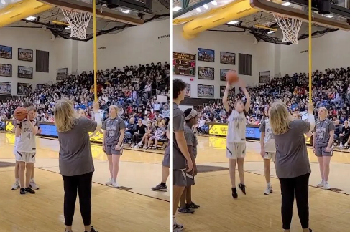  What do you see in the picture, where is it, what do you think is happening?  The photo shows High School basket ball player, Jules Hogland, taking a shot during a match. But there is something different about Jules - he is blind. So, how does Jules take the shot?  The picture poses the question, "Can a person who can't see play basketball?"  The article accompanying the picture says, "When inclusion is the goal, human beings can figure out all kinds of ways to make the seemingly impossible happen."  To make sure the game was accessible for Jules, a fellow player tapped the hoop with a long stick. Another player positioned James and then the crowd remained silent for the shot. You can watch the shot in the clip which is in the article. The crowd are absolutely silent as the shot is taken and then they erupt when it goes in.  The article says, "Not only was it a great shot, it was an awesome example of what support and inclusion can look like from a school and a community."  "The goal is not for those without disabilities to "help" those with, rather, it's a way to empower everyone to have fun together through sports. Teammates work together to play their personal and collective best for the good of the team."  - how is basketball played?  - what are the challenges for a player who is blind?  - Can disabilities make some things impossible?  - "When inclusion is the goal, human beings can figure out all kinds of ways to make the seemingly impossible happen." - how? What does that mean?  - Can you think of any examples where people who are differently abled can play sport in a different way?  - Should we consider language in this story? Does it matter if the term disability is used or the the term differently abled - does it make any difference?  - "The goal is not for those without disabilities to "help" those with," - why not?  - Why do the crowd go silent in the video?  - There are hundreds of people in the room, all silent. would it have been really funny if one person had sneezed loudly or shouted out? Would everyone have laughed?  - "It was an awesome example of what support and inclusion can look like from a school and a community." what does this mean?  - what does 'collective best' mean?  - What can we learn from Jules?  - What can we learn from the crowd?  - Why is this about No Outsiders?  No Outsiders: Everyone different, everyone welcome by Andrew Moffat | https://www.youtube.com/watch?v=wJwfPl4X5-Q  https://www.youtube.com/watch?v=saPBcL4-TdI&list=PLcvEcrsF_9zKeottK5KyBaMkfH7N-R_-N&index=1 | Luke 6:35 Love your enemies! Do good to them. Lend to them without expecting to be repaid.
7 | The Equality act  Summing up the themes of the week  We know we are all different | Difference  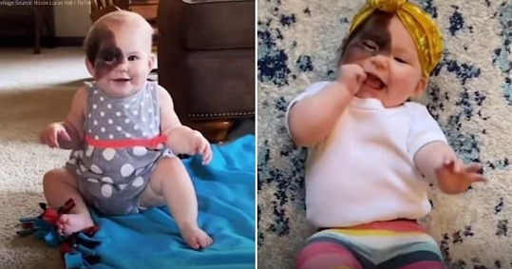  https://scoop.upworthy.com/this-mom-is-on-a-mission-to-show-her-daughter-who-has-a-rare-birthmark-that-shes-beautiful?fbclid=IwAR0hXiZvnN5D8grKkcfO5YldscSHV7oFYo1jrGe9D4zLp5IiyRXjkIA7krE  Winry Hall is a happy, healthy, confident 13 month old baby who is a bundle of joy, always laughing. Winry was born with a birthmark on her face so she looks different to other babies. Winry's mother is using social media to reimagine beauty standards and show her baby that she is beautiful.  Mum says, "For a lot of people, this is the first time seeing a birth mark like hers and that's part of why I enjoy sharing. This is a good conversation for parents with their children to see kids have differences, or for those parents who do have a kid that looks like Winry or has any kind of birthmark, to see their child represented."  Mum says being different can be a child's superpower.  As Winry grows older, she will have to be careful to use sunscreen and wear hats to protect her skin, but Mum says her biggest worry is bullying at school, and experiences she might have in her childhood.  "A lot of that comes from ignorance and not having seen this before. Before I had her in my arms, I had not seen a birthmark like this either. It doesn't upset me that others haven't seen it but I just wish that was different. I really feel like the more you see differences the more normalised they will be." That is why Mum is sharing photos and videos on social media.  Since sharing photos of Winry, Mum has met many other people with birthmarks who she says radiate positivity which is heart warming and has given her support. Mum says 20 years from now she just wants Winry to be doing whatever makes her happy as she can do whatever she sets her heart on.  what do you see in the picture, what do you think this story is about?  - what is a birth mark? (the proper medical term is congenital melanocytic nevi, or CNN)  - "re-imagine beauty" what does that mean?  - who decides what is beautiful and not beautiful in society? How do we get these messages?  - Despite a slightly increased need to protect her baby's skin from the sun, Mum's bigger worry is bullying by other children - why?  - where does bullying come from?  - "the more you see differences the more normalised they will be." what does this mean?  - There is a video in the link were we can see Winry has a doll that looks like her - why do you think that is important for Winry?  - should Mum be worried about bullying? If Winry came to our school, would that be a problem?  - Mum has met many people with birthmarks who "radiate positivity" why do you think that is?  - "being different can be a child's superpower." - how can that be?  - what can we learn from Winry?  - Why is this about No Outsiders?  No Outsiders: Everyone different, everyone welcome by Andrew Moffat |  | All people are morally equal before the throne of God facing the law and His mercy. We all have equal responsibility to use what we have to the glory of God. Every human being is the object of the love of God (John 3:16)

HRH12.5.22

