Safe Relationships
Recognising and managing pressure; consent in different situations
Families and friendships
Attraction to others; romantic relationships; civil partnership and marriage
Respecting ourselves and others
Expressing opinions and respecting other points of view, including discussing topical issues

What will be my PSHE learning by the time we leave Year 6
Belonging to a community
Valuing diversity; challenging discrimination and stereotypes
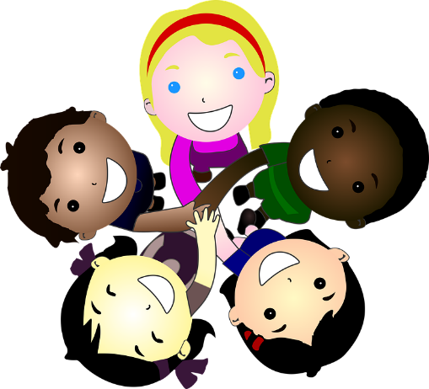
Money and work
Influences and attitudes to money; money and financial risks
Media literacy and digital resilience
Evaluating media sources; sharing things online

Keeping safe
Keeping personal information safe; regulations and choices; drug use and the law; drug use and the media
Physical health and Mental wellbeing
What affects mental health and ways to take care of it; managing change, loss and bereavement; managing time online
Growing and changing
Human reproduction and birth; increasing independence; managing transition

