Respecting ourselves and others
Responding respectfully to a wide range of people; recognising prejudice and discrimination
Safe Relationships
Physical contact and feeling safe
Families and friendships
Managing friendships and peer influence

What will be my PSHE learning by the time we leave Year 5
Belonging to a community
Protecting the environment; compassion towards others
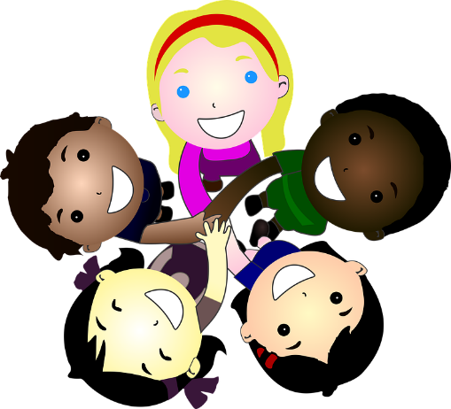
Money and work
Identifying job interests and aspirations; what influences career choices; workplace stereotypes
Media literacy and digital resilience
How information online is targeted; different media types, their role and impact

Physical health and Mental wellbeing
Healthy sleep habits; sun safety; medicines, vaccinations, immunisations and allergies
Growing and changing
Personal identity; recognising individuality and different qualities; mental wellbeing
Keeping safe
Keeping safe in different situations, including responding in emergencies, first aid

