Respecting ourselves and others
Respecting differences and similarities; discussing difference sensitively
Safe Relationships
Responding to hurtful behaviour; managing confidentiality; recognising risks online
Families and friendships
Positive friendships, including online

What will be my PSHE learning by the time we leave Year 4
Belonging to a community
What makes a community; shared responsibilities
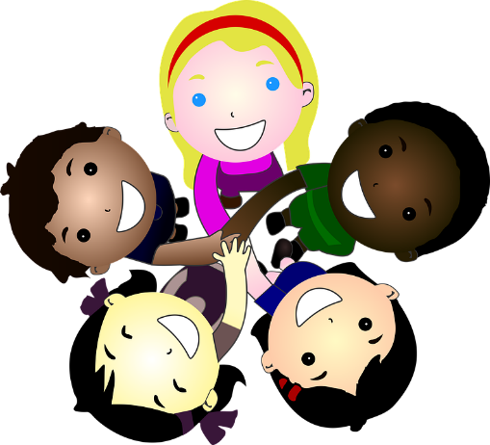
Money and work
Making decisions about money; using and keeping money safe
Media literacy and digital resilience
How data is shared and used
Growing and changing
Physical and emotional changes in puberty; naming body parts, personal hygiene routines; support with puberty
Physical health and Mental wellbeing
Maintaining a balanced lifestyle; oral hygiene and dental care
Keeping safe
Medicines and household products; drugs common to everyday life

