Respecting ourselves and others
Recognising respectful behaviour; the importance of self-respect; courtesy and being polite

Safe Relationships
Personal boundaries; safely responding to others; the impact of hurtful behaviour
Families and friendships
What makes a family; features of family life

What will be my PSHE learning by the time we leave Year 3
Belonging to a community
The value of rules and laws; rights, freedoms and responsibilities
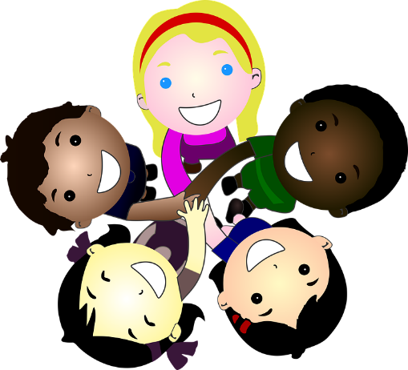
Money and work
Different jobs and skills; job stereotypes; setting personal goals
Media literacy and digital resilience
How the internet is used; assessing information online

Physical health and Mental wellbeing
Health choices and habits; what affects feelings; expressing feelings
Growing and changing
Personal strengths and achievements; managing and reframing setbacks
Keeping safe
Risks and hazards; safety in the local environment and unfamiliar places

