Safe Relationships
Managing secrets; resisting pressure and getting help; recognising hurtful behaviour
Respecting ourselves and others
Recognising things in common and differences; playing and working cooperatively; sharing opinions
Families and friendships
Making friends; feeling lonely and getting help

What will be my PSHE learning by the time we leave Year 2
Belonging to a community
Belonging to a group; roles and responsibilities; being the same and different in the community
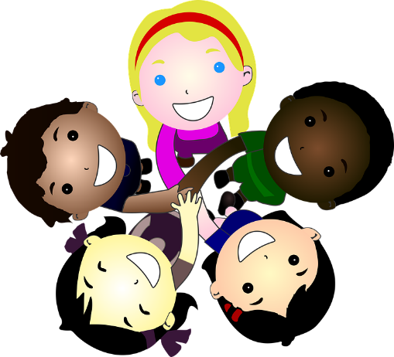
Media literacy and digital resilience
The internet in everyday life; online content and information
Money and work
What money is; needs and wants; looking after money

Physical health and Mental wellbeing
Why sleep is important; medicines and keeping healthy; keeping teeth healthy; managing feelings and asking for help
Growing and changing
Growing older; naming body parts; moving class or year
Keeping safe
Safety in different environments; risk and safety at home; emergencies

