Respecting ourselves and others
How behaviour affects others; being polite and respectful
Safe Relationships
Recognising privacy; staying safe; seeking permission
Families and friendships
Roles of different people; families; feeling cared for

What will be my PSHE learning by the time we leave Year 1
Belonging to a community
What rules are; caring for others’ needs; looking after the environment
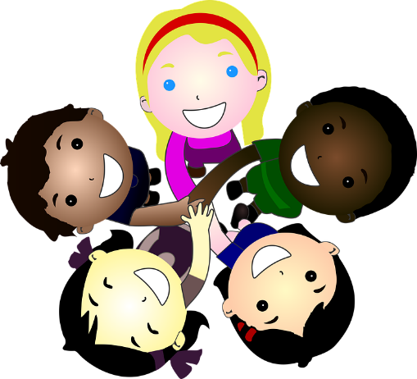
Media literacy and digital resilience
Using the internet and digital devices; communicating online
Money and work
Strengths and interests; jobs in the community

Physical health and Mental wellbeing
Keeping healthy; food and exercise, hygiene routines; sun safety
Growing and changing
Recognising what makes them unique and special; feelings; managing when things go wrong
Keeping safe
How rules and age restrictions help us; keeping safe online

