Families and friendships
Relationship, attraction, healthy, commitment, love, marriage
Respecting ourselves and others
Values, behaviours, respect, disagreements, conflict, views, listen
Safe Relationships
Friendship, pressure, dares, unsafe, worried, guidance, support

What VOCABULARY will I need to know
and use in my PSHE learning in Year 6
Belonging to a community
Prejudice, discrimination, challenge, serotypes, influence
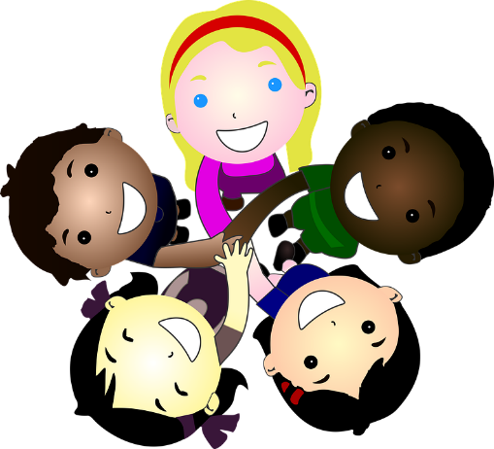
Media literacy and digital resilience
Contacting, communicating, safety, social media, sharing, age restrictions, connecting

Money and work
Role, value, work, finances, risk, gambling

Keeping safe
online, images, appropriate, text, share, restrictions, laws, drugs, organisations, media
Physical health and Mental wellbeing
Feelings, mental health, conflict, support, changes, bereavement, balance, online
Growing and changing
Independence, changes, secondary, routines, intercourse, contraception

