Families and friendships
Healthy, friendships, relationship, influence, communication, support, peer
Safe Relationships
Permission, contact, uncomfortable, unacceptable, secret, worried, concerned
Respecting ourselves and others
Treated, equally, respect, discrimination, bullying, online, report, safety

What VOCABULARY will I need to know
and use in my PSHE learning in Year 5
Belonging to a community
Resources, protecting, environment, actions, compassion, responsibility

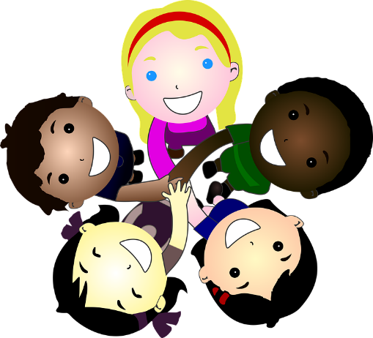
Money and work
Jobs, ambition, career, conditions, inclusion, diversity
Media literacy and digital resilience
Identify, purpose, fact, opinion, stereotypes, reliable, information

Physical health and Mental wellbeing
Lifestyle, healthy, outdoors, sun safety, illness, cleanliness, virus, allergies
Growing and changing
personal identity, gender, recognise, respect, express, well being
Keeping safe
Unsafe, emergency, risk, injuries, responsibility

