Safe Relationships
Differentiate, experiences, bullying, dares, pressures, confidence, harmful, pretending
Families and friendships
Friendships, positive, digital devices, communicating, contact, online, healthy
Respecting ourselves and others
Recognise, gender, race, faith, values, respect, differences, include

What VOCABULARY will I need to know
and use in my PSHE learning in Year 4
Belonging to a community
Community, belonging, differences, volunteering, compassion, responsibilities
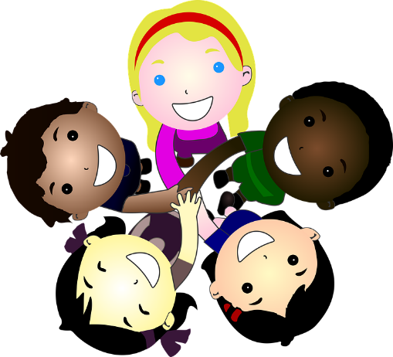
Media literacy and digital resilience
digital footprint, organisations, online, adverts, fact/ fiction
Money and work
Budgets, value, important, payment, charities

Physical health and Mental wellbeing
Balance, healthy, recognise, illness, support, care, dental health

Growing and changing
Identify, hygiene, emotion, help, puberty, information
We will name external body parts
Keeping safe
Medicines, drug, cigarettes, habit, e-cigarettes, vaping

