Safe Relationships
Family, classmates, boundaries, respect, safe, behaviour, bullying
Respecting ourselves and others
Respect, help, responsible, self-respect, polite, cultures, society
Families and friendships
Recognise, respect, stability, love, support, caring, unsafe

What VOCABULARY will I need to know
and use in my PSHE learning in Year 3
Belonging to a community
Laws, society, human rights, responsibilities, rights, police
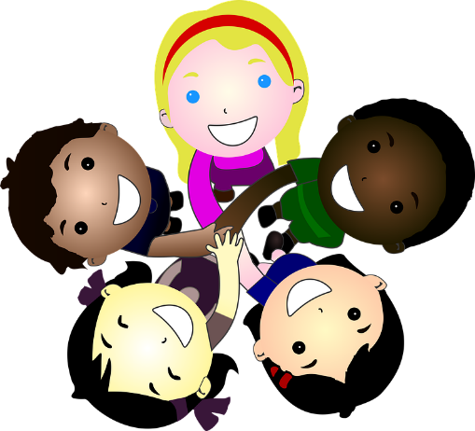
Money and work
Jobs, vocation, myths, stereotypes, teamwork, achievements
Media literacy and digital resilience
Leisure, online, reliable, websites, choices

Physical health and Mental wellbeing
Choices, healthy, unhealthy, influence, habits, lifestyle, physical
Growing and changing
Valuable, contributions, self-worth, setbacks, challenges, identity
Keeping safe
Hazards, risks, alarms, safety, rules, environment

