Safe Relationships
Online, bullying, feelings, differences, secrets, uncomfortable, worried
Families and friendships
Kindness, listening, honesty, friends, inclusion, arguments, help
Respecting ourselves and others
Classmates, friends, common, differences, groups, situations, discussions, reasons

What VOCABULARY will I need to know
and use in my PSHE learning in Year 2
Belonging to a community
Groups, roles, teams, faiths, responsibilities, community
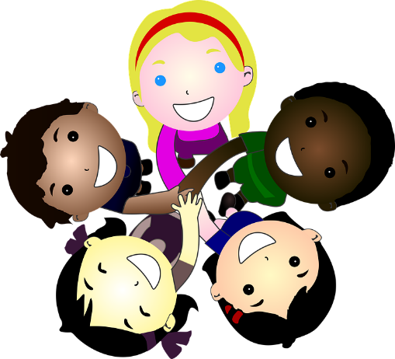
Media literacy and digital resilience
Internet, purpose, value, content, recognise
Money and work
Currency, jobs, banks, savings, money, spending

Growing and changing
life cycle, human, bodies, responsibilities, goals, changes
We will name the body parts with correct names
Physical health and Mental wellbeing
Routines, mental health, growing, changing, teeth, dentist, feelings, bereavement
Keeping safe
Medicines, safety, unsafe, danger, accident, emergency

