Safe Relationships
feeling’s, help, private, uncomfortable, safe, unsafe, permission
Families and friendships
Friends, teachers, parents, sibling, grandparents, relatives, families
Respecting ourselves and others
Behaviour, school, kind, feeling’s, respect, polite, rules, sharing

What VOCABULARY will I need to know
and use in my PSHE learning in Year 1
Belonging to a community
Rules, care, environment, recycling, differences
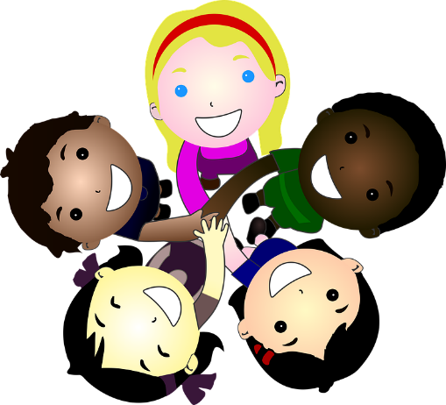
Media literacy and digital resilience
Internet, digital, devices, safety, online
Money and work
Strengths, interests, community, jobs, work

Physical health and Mental wellbeing
Healthy, hygiene, care, unhealthy, balance, safe
Growing and changing
Unique, special, same, different, feelings, recognise
Keeping safe
Safe, restrictions, online, trust, feelings

