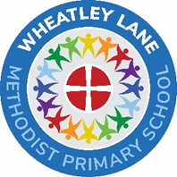

With God’s help, we do all we can to be the best we can be.
All you need is LOVE.

Religious Education Policy
Date | February 2025
Review | Spring 2028
Chair of Governors | Mr Andrew Stickland
Head teacher | Mrs Tracy Hallows
RE Subject Leader | Mrs Tracy Hallows



Religious Education in a Church School should be of the highest standard, always striving for excellence, reflecting the school’s distinctive Christian character.

RE Mission Statement
Within the context of this Church School, RE will support our pupils in developing their own beliefs, values and attitudes through an exploration of shared human experience, the place and significance of Christianity and other religions in the contemporary world. An emphasis will be on Methodist beliefs and practices appropriate to the school situation. RE will play a major part in promoting the Christian ethos of the school reflected in our Vision and Mission.
Responsibility
In Voluntary Aided Schools the management of RE is a distinctive role of the governors and headteacher. RE has to be in accordance with the Trust Deed and in accordance with the rites, practices and doctrines of the Methodist Church. The Governing Body as a whole is responsible for determining the nature of Religious Education provided in its school. Although RE and Collective Worship naturally compliment and enrich one another they should be managed separately.
RE in a Church School lies at the very heart of the curriculum
In our school
- The Governors have adopted the Blackburn Diocesan Board of Education Syllabus for RE which reflects the National Framework for RE.
- The Methodist units of work are delivered in Year 2,4 and 6.
- Understanding Christianity is used as a resource to support the teaching of RE.
- At least 5% of curriculum time is devoted to RE (80% Christianity, 20% other faiths – Islam and Judaism will be taught in both Key Stages. Hinduism, Buddhism and Sikhism will be taught during their time in our school (see appendix)

“Christianity should be the majority study in RE in every school. In Church schools that should be clearly adhered to. KS 1 – 3 at least 2/3rds of RE curriculum is to be Christianity. Sufficient dedicated curriculum time, meeting explicitly RE objectives, however organised, should be committed to the delivery of RE. This should aim to be close to 10% but must be no less than 5%.”
RE Statement of Entitlement: The Church of England Education Office 2016

It is important that the teaching of RE at Wheatley Lane Methodist VA Primary School equips the pupils to recognise the common search of all humanity for ultimate truth and relationship with the divine. It is entirely appropriate and necessary in today’s world, therefore, that respect for the great world faiths is fostered in RE within a Church School. This respect must be based on an accurate and sympathetic understanding of the other faiths which is consistent with the school’s loyalty to its Christian foundation.
“Pupils can expect that a Church school RE curriculum will engage and challenge them through an exploration of core concepts and questions. They can expect Church schools to provide meaningful and informed dialogue with a range of religions and worldviews.” RE Statement of Entitlement: The Church of England Education Office 2019 (see appendix 3)

Aims and objectives of RE in a Church School

- To know about and understand Christianity as a diverse global living faith through the exploration of core beliefs using an approach that critically engages with biblical text.
- To gain knowledge and understanding of a range of religions and worldviews appreciating diversity, continuity and change within the religions and worldviews being studied.
- To engage with challenging questions of meaning and purpose raised by human existence and experience.
- To recognise the concept of religion and its continuing influence on Britain’s cultural
- heritage and in the lives of individuals and societies in different times, cultures and places.
- To explore their own religious, spiritual and philosophical ways living, believing and thinking.
RE Statement of Entitlement: The Church of England Education Office 2019

Appropriate to age at the end of their education in Church schools the expectation is that
all pupils are religiously literate and, as a minimum, pupils are able to:
- Give a theologically informed and thoughtful account of Christianity as a living and diverse faith.
- Show an informed and respectful attitude to religions and world views in their search for God and meaning.
- Engage in meaningful and informed dialogue with those of other faiths and none.
- Reflect critically and responsibly on their own spiritual, philosophical and ethical convictions.

This can be expressed in more detail and distinctively as:
We learn about
- God who reveals the truth about himself and humanity through creation, the giving of the law, his action in history and through the prophets;
- God who reveals himself ultimately in Jesus his Son, living among us and dying and rising for us;
- God who reveals himself in his Spirit working in the living faith of the Church experienced through scripture, tradition and reason.
We learn from
- an empathetic response to the Christian faith and a critical engagement with it;
- responding personally to the stories and teachings of Jesus Christ;
- examples of Christian living which give priority to the values of unconditional love, forgiveness, reconciliation, justice, compassion and faith.

Religious Education in Church Schools should also help pupils to:
- learn about other faiths, their beliefs, traditions and practices and from them through encounter and dialogue;
- recognise and respect those of all faiths in their search for God;
- recognise areas of common belief and practice between different faiths;
- enrich and expand their understanding of truth while remaining faithful to their own tradition;
- enrich their own faith through examples of holy living in other traditions.

Religious Education in Church Schools should help pupils to:
- reflect theologically and explore the ultimate questions and challenges of life in today’s society;
- reflect critically on the truth claims of Christian belief;
- see how the truth of Christianity is relevant today;
- understand the challenge faced by Christians in today’s pluralist and post-modern society;
- develop the skills to handle the Bible text;
- recognise that faith is based on commitment to a particular way of understanding God and the world;
- begin to develop their own commitments, beliefs and values;
- develop a sense of themselves as significant, unique and precious;
- experience the breadth and variety of the Christian community;
- engage in thoughtful dialogue with other faiths and traditions;
- become active citizens, serving their neighbour;
- find a reason for hope in a troubled world;
- understand how religious faith can sustain believers in difficult circumstances and in the face of opposition.;

Religious Education in Church Schools should enable:
- pupils and teachers to talk openly and freely about their own personal beliefs and practice without fear of ridicule;
- pupils to make excellent and appropriate progress in their knowledge and understanding of Christianity;
- pupils from Christian families to talk openly about their beliefs and values in lessons and to grow in their faith;
- pupils from other faith backgrounds to understand and be encouraged in their faith;
- pupils with no religious background to be given an insight into what it means to be a person of faith;
- pupils of all backgrounds to have a safe place to explore the ultimate questions and challenges of life in today’s society.

RE can contribute significantly to pupils’ Spiritual, Moral Social and Cultural development.
Spiritual development within RE in a Church School enriches and encourages the pupils’ discovery of God the creator, of their ‘inmost being’ and of the wonder of the environment. Moral development is based on the teachings of Jesus Christ, which offer pupils a secure foundation stone on which to make decisions and build their lives.
Social development enriches pupils’ understanding of what it means to live in a Christian community where Jesus’ command to love one another is put into practice. Cultural development provides opportunities to develop an understanding of Christianity as a worldwide, multi-cultural faith that has an impact on the lives of millions of people.
SEND Children
We recognise the individual needs of all our children and through the process of differentiation and support we aim to help them reach their full potential. This applies to pupils of differing ability levels including pupils with Special Educational Needs, different ages and experiences, English as an Additional Language and able and talented children.
Resources
RE resources are stored in the staffroom cupboards.
There is an annual budget for RE but if extra resources are required these can often be purchased through the Friends of Wheatley Lane.
Assessment and Record Keeping
Ongoing assessments and evaluations are carried out within each class to ensure lessons and activities are challenging and creative. Class teachers will use the assessment grids at the end of the RE units to stick in the children’s books then both child and teacher can assess together at the end of each unit. The RE co-ordinator will also carry out curriculum walkthroughs to ensure the teaching and planning of RE reflect the importance of the subject and the level at which activities are aimed. The RE co-ordinator, alongside class teachers will assess pieces of work across the school and display in a portfolio or scrapbook; book monitoring will also take place through book scrutinies during the year . The school is currently using scrapbooks to display work, show progression in year groups, through year groups and to show the attainment and standard of RE across the school. Work in these scrapbooks is also assessed using the ‘Learning Ladders’. Annual written reports which include RE are sent to parents.

Finally it is vital that this RE Policy includes the Parental Rights of Withdrawal in a Voluntary Aided School.
Parents may request the governing body to provide Religious Education for their children according to the Agreed Syllabus. This can only be requested when parents cannot, with reasonable convenience, arrange for their children to attend another school where Religious Education is provided according to the Agreed Syllabus. The governing body should make provision unless the circumstances make it unreasonable to do so.

Should the governing body be unable to make such arrangements for Religious Education to be delivered according to the Agreed Syllabus, the responsibility for doing so then falls on the Local Authority. The Local Authority may decide that such a request for separate Religious Education is unreasonable and the parental request then fails.

Parents may withdraw their children from Religious Education as they may in any school and this opportunity must be described in the school brochure. The Church of England Board of Education and the Methodist Church suggests an appropriate form of words might be:

‘ The Worship and Religious Education provided by the school is in accordance with the Church of England or Methodist Church Foundation. This foundation is also reflected in the curriculum and the whole life of the school community. Since the conduct of the school as a whole reflects the Church of England or Methodist Church ethos, removal of pupils from Worship and/or Religious Education (as parents are legally entitled to do) cannot insulate them from the religious life of the school.’

If such a request for withdrawal is made, the Headteacher should explore the reasons for the request and seek to arrive at an accommodation. It may be that only some elements of Religious Education or Worship are objected to.
Parents may request the governing board to provide Religious Education for their children according to the locally Agreed Syllabus. This can only be requested when parents cannot, with reasonable convenience, arrange for their children to attend another school where Religious Education is provided according to the locally Agreed Syllabus. The governing board should make provision unless the circumstances make it unreasonable to do so.
Should the governing board be unable to make such arrangements for Religious Education to be delivered according to the Agreed Syllabus, the responsibility for doing so then falls on the Local Authority. The Local Authority may decide that such a request for separate Religious Education is unreasonable and the parental request then fails.

Head teacher – Mrs Hallows
RE Co-ordinator – Mrs Hallows and Mrs Butterfield
Policy Date – April 2019
This policy is a working document and therefore open to change and restructuring as and when the need arises. To be reviewed 3 yearly.

Religious Education Units of Work

 | Autumn |  | Spring |  | Summer
 | 1 | 2 | 1 | 2 | 1 | 2
Reception | EYFS I am special  EYFS Harvest  UC F1 Creation | EYFS Christmas  UC F2 Incarnation | EYFS Special Places  Church + Mosque | EYFS Easter  UC  F3 Salvation | EYFS Stories Jesus heard | EYFS Stories Jesus told
Year 1 | 1.1 Harvest  + Jewish Sukkot  1.2God and Creation  + Hindu creation story  UC 1.2 Creation | 1.3 Christmas  Giving and receiving gifts  UC 1.3 Incarnation | 1.4 Jesus was special | 1.5 Easter  New Life  UC 1.5 Salvation | 1.7 Why is Baptism special?  + Muslim birth rites | 1.8 Joseph
Year 2 | Belonging Together  Methodist Unit  UC 1.1 God  Jesus friend to everyone  UC 1.4 Gospe | 2.2 Christmas  Good News | 2.4 Easter  Signs and Symbols  UC 1.5 Salvation | 2.6 Ascension and Pentecost | l2.1 The Bible  + Judaism – the Torah  + Sikhism – the Guru Granth Sahib | 2.5 Why is the church a special place for Christians?  +Why is the mosque a special place for Muslims
Year 3 | 3.6 Harvest  + Judaism- Sukkot | 3.2 Christmas  God with us | 3.3 Jesus the Man who changed lives  UC Unit 2A.4 What kind of world did Jesus want? | 3.4 Easter  Sadness and Joy  Crosses around the world  UC Unit 2A.5 Why do Christians call the day Jesus died Good Friday? | 3.1 Called by God  + Islam – Prophet Muhammed  UC 2A:2 What is it like to follow God? | 3.5 Which Rules should we follow?  UC Unit 2B.3 People of God. How can following God bring freedom and justice?
Year 4 | 4.1 God, David and the Psalms | 4.2 Christmas  Light  + Judaism, Hanukkah | 4.6 What is prayer?  + Islam -Prayer | 4.4Easter  Betrayal and trust  UC Unit 2A.5 Why do Christians call the day Jesus died Good Friday? | Warm Hearts  Methodist Unit  UC Unit 2a.6 Kingdom of God | 4.5 Are all churches the same?  +Sikh – Gudwara visit
Year 5 | 5.1 How and why do Christians read the Bible?  + Hinduism - Scriptures | 5.7 Christmas  Christmas around the world | 5.6 Loss, death and Christian hope  +Buddhism –end of life ritual  Understanding Christianity Unit 2B.7 What difference does the resurrection make to Christians? | 5.4 Easter  Why do Christians believe Easter is a celebration of victory  Understanding Christianity Unit 2B.6 (Year 5) What did Jesus do to save human beings? | 5.5 Significant Women in the Old Testament  + Judaism – Purim (Story of Esther) | 6.7 People of faith  (including Charles and John Wesley)
Year 6 | 6.1 Life as a journey and pilgrimage  + Islam - Hajj | 6.2 Christmas  How do Christians prepare for Christmas  Understanding Christianity Unit 2B.4 Was Jesus the Messiah? | 6.3 Why do Christians celebrate the Eucharist?  +Judaism - Passover | Easter  Who was Jesus? | Commitment to Christianity  Methodist Unit | 6.6 Ideas about God  + Muslim and Hindu  UC 2b.1 God

APPENDIX 2


Religious Education in Church of England Schools
A Statement of Entitlement

Religious education in a Church school should enable every child to flourish and to live life in all its fullness. (John 10:10). It will help educate for dignity and respect encouraging all to live well together
Such an approach is offered through a commitment to generous hospitality, being true to our underpinning faith, but with a deep respect for the integrity of other religious traditions (and worldviews) and for the religious freedom of each person.1

A high-quality sequential religious education2 (RE) programme is essential to meet the statutory requirement for all state funded schools, including academies and free schools, to teach a full curriculum that prepares pupils for the opportunities, responsibilities and experiences of life in modern Britain. Central to religious education in Church schools is the study of Christianity as a living and diverse faith, focused on the teaching of Jesus and the Church. There is a clear expectation that as inclusive communities, church schools provide sequenced learning about a range of religions and worldviews3 fostering respect for others. In voluntary aided schools, RE must be taught in accordance with the trust deed: this document will help schools interpret that legal requirement. In foundation and voluntary controlled schools with a religious character, RE

1 The Church of England Education Office, Church of England Vision for Education: Deeply Christian, Serving the Common Good. (The Church of England Education Office, 2016), available at https://www.churchofengland.org/more/education-and-schools/vision-education
2 Section 48 of the 2005 Education Act requires the inspection of religious education in schools which have a religious character. The term religious education (RE) is therefore used throughout this document as it is connected to the Section 48 SIAMS inspection and, if and until the law changes we will need to continue to use the term. This does not stop individual schools, MATs or dioceses using other names including Religion and Worldviews for the subject.
3 The term worldviews is used throughout the document to refer to a person’s way of understanding, experiencing and responding to the world. It can be described as a philosophy of life or an approach to life. It could refer to an ‘institutional’ worldview to describe organised worldviews including religions as well as Humanism, Secularism and Atheism or a ‘personal’
worldview for an individual’s way of understanding and living in the world which may be drawn from one or many institutionalised worldviews. Based on Commission on Religious Education, Religion and worldviews: The way forward A national plan for RE (Religious Education Council for England and Wales 2018) p4.
must be taught according to the locally agreed syllabus for RE unless parents request RE in accordance with the trust deed of the school. In academies and free schools RE must be taught in accordance with the funding agreement.
The effectiveness of denominational education in Church schools is evaluated during the statutory inspection of Anglican and Methodist schools (SIAMS) section 48 inspection. That subsequent judgement will reflect the expectations set out in this document. The SIAMS evaluation schedule assesses the way RE contributes to the outworking of church school’s Christian vision. It highlights the responsibility of Church school leaders to ensure that pupils flourish academically through the provision of high-quality RE. In addition, in voluntary aided schools, a judgement on standards in teaching and learning in RE is included in the SIAMS report.

The Entitlement: provision, profile and priority
In a Church school the pupils and their families can expect an RE curriculum that enables pupils to acquire a rich, deep knowledge and understanding of Christian belief and practice, this should include the ways in which it is unique and diverse. Parents can expect the use of high-quality resources, for example, the Understanding Christianity resource. Pupils can expect that teaching and learning in Church schools will use an approach that engages with biblical text and theological ideas.
Pupils can expect that a Church school RE curriculum will engage and challenge them through an exploration of core concepts and questions. They can expect Church schools to provide meaningful and informed dialogue with a range of religions and worldviews. There should be opportunities for them to understand the role of foundational texts, beliefs, rituals, and practices and how they help form identity in a range of religions and worldviews. Pupils should explore how these may change in different times, places and cultures. RE will go beyond a sociological study of religious phenomena and will introduce pupils to a range of relevant disciplines including theology, philosophy and the human and social sciences. In all Church schools progress in RE should be significant and attainment high enabling pupils to develop confident religious literacy.
Parents and pupils can expect that in a Church school RE will have a high profile within the curriculum and will be a priority for senior leaders. The RE curriculum is intrinsic to the outworking of a Church school’s Christian vision in enabling all pupils to flourish. In addition, the RE curriculum will contribute to British values and spiritual moral social and cultural development
Learning activities must provide fully for the needs of all pupils. Pupils should develop a wide range of skills including enquiry, analysis, interpretation, evaluation and reflection. Pupils should have a safe space to explore their own religious, spiritual and/or philosophical ways of seeing, living and thinking, believing and belonging. They should have opportunities to engage in meaningful and informed dialogue with those of all religions and worldviews.

Curriculum statement: challenging, accurate and diverse

In all Church schools religious education must be considered an academic subject. All pupils are entitled to religious education that is delivered in an objective, critical and pluralistic manner. Pupils are entitled to a balanced RE curriculum which enquires into religions and worldviews

3

through theology, philosophy and the human and the social sciences. It should be a coherent curriculum that enables progress through ordered and sequential learning developing both knowledge and skills. There should be a clear curriculum vision and intent, a structure for implementation and provision and a process for evaluating impact.

Aims and objectives
- To know about and understand Christianity as a diverse global living faith through the exploration of core beliefs using an approach that critically engages with biblical text.
- To gain knowledge and understanding of a range of religions and worldviews appreciating diversity, continuity and change within the religions and worldviews being studied.
- To engage with challenging questions of meaning and purpose raised by human existence and experience.
- To recognise the concept of religion and its continuing influence on Britain’s cultural
heritage and in the lives of individuals and societies in different times, cultures and places.
- To explore their own religious, spiritual and philosophical ways living, believing and thinking.

Curriculum balance and time: sufficient, appropriate and balanced
Reflecting the school’s trust deed or academy funding agreement parents and pupils are entitled to expect that in Church schools Christianity should be the majority religion studied in each year group and should be at least 50% of curriculum time. Sufficient dedicated curriculum time, meeting explicitly RE objectives, however organised, should be committed to the delivery of RE. This should aim to be close to 10% but must be no less than 5% in key stages 1-4.

All pupils in Church schools should follow a recognised and appropriate qualification or course in RE or Religious Studies at KS 4. This includes pupils who have SEND. The study of Christianity will be a significant part of any Religious Studies qualification offered.

The school must make it possible for those students who achieve suitable grades at GCSE or equivalent to follow appropriate A level courses. This should be in addition to the provision of core RE entitlement for all students at KS5 which should continue to develop student’s understanding of Christianity and other religions and worldviews.
Schools must take note that the RE entitlement is totally separate from requirements for collective worship. Collective worship must not be considered curriculum time for RE or the teaching of RE.

Developing staff expertise and knowledge: confidence specialism professionalism
Pupils in Church schools are entitled to be taught by teachers who have a secure subject knowledge and are confident in helping them navigate and challenge cultural and religious stereotypes, prejudice and extremism. It should be a priority in Church schools to build up staff expertise in RE specifically, but not exclusively, working towards:
- at least one member of staff having RE qualifications or receiving specialist training.

- secondary schools employing specialist RE teachers and deploying them effectively to ensure pupils receive specialist teaching.
- all staff teaching RE having access to subject specific professional development.
- all staff teaching RE knowing how to create and maintain classrooms in which academic rigour is balanced with respect for different personal beliefs and identities.
- all teaching staff and governors understanding of the distinctive role and purpose of RE within church schools.
- a governing body which is monitoring standards in RE effectively.

The role of the Diocesan Boards of Education
One function of Diocesan Boards of Education (DBEs) is to promote, or assist in the promotion of, religious education in schools in the diocese. This should be fulfilled by monitoring the quality of religious education in Church schools through taking note of SIAMS inspection reports and by securing high quality training for all schools throughout the diocese. This will help ensure that the provision for religious education is effective and is able to fulfil the expectations of this statement.

Support for effective and excellent RE
Teachers in Church schools belong to a wider educational and church community.
They are entitled to expect positive support in providing effective and excellent religious education from:
- a named member of staff responsible for religious education and where that person is the headteacher someone who shadows the role
- their senior management team and their governing body, especially foundation governors or academy equivalents
- their local Diocesan Board of Education, including a school’s adviser with an appropriate religious education background
- the Church of England Education Office
- local clergy and other minsters and Christian communities.

Derek Holloway
School Character and SIAMS Development Manager February 2019

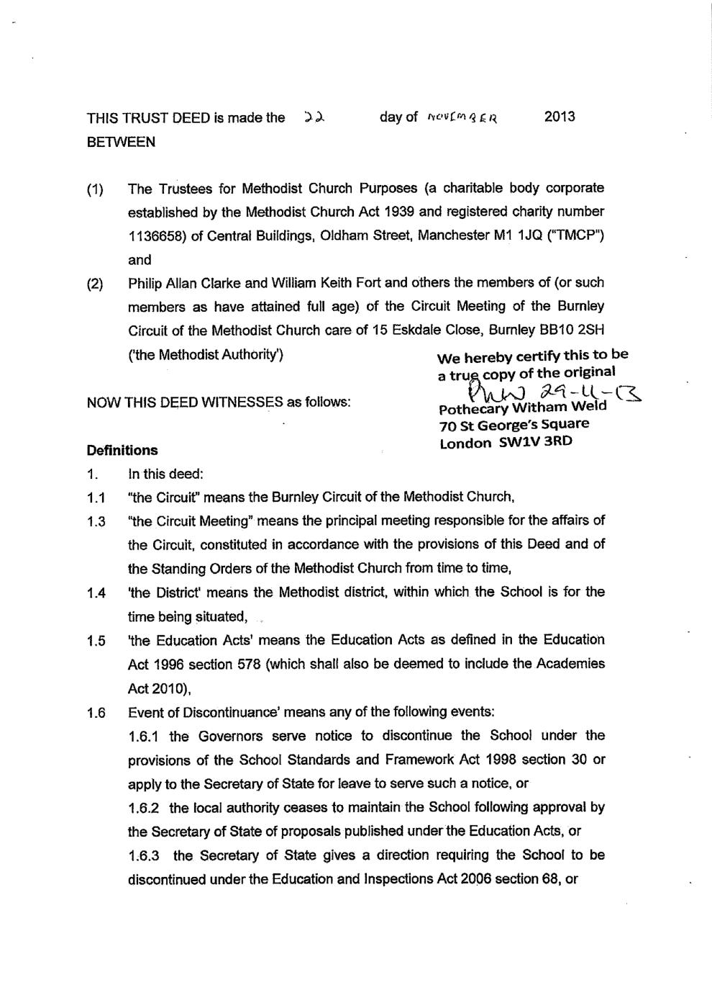
Appendix 3



